**GeoServer with SAP HANA**



**1 Basic Features of GeoServer:**

* Open-source server written in Java that allows users to publish, share, process and edit geo-spatial data from anywhere across the web.
* Publishes data from several data sources including SAP HANA using open standards.
* Connecting existing information to Virtual Globes such as Google Earth and NASA World Wind as well as to web-based maps such as Open-Layers, Google Maps and Bing Maps.
* Offers implementation of the OGC standardized services such as WFS (Web Feature Service), WMS (Web Map Service), WCS (Web Coverage Service), and WPS (Web Processing Service).

For more information about GeoServer, you can find their user manual here: <http://docs.geoserver.org/stable/en/user/>

**2 Install and configure GeoServer on Local Machine with SAP HANA Extension:**  
  
Follow the following steps when installing GeoServer on your local machine:

1. **Install Java.** To use the latest version of GeoServer, JRE 1.8 is essential.
2. **Download or Install GeoServer.** To use SAP HANA as the data-source it is required to download the latest development release which nightly builds for the master branch. It can be found here: <http://geoserver.org/release/master/>. Follow one of the guides available at <http://docs.geoserver.org/stable/en/user/installation/index.html> for detailed steps to configure and run GeoServer on your operating system.
3. **Download the SAP HANA Extension to GeoServer.** To enable SAP HANA functionalities, the extension library (a single JAR file) has to be downloaded separately from \\trextest\trex_test\gis\03_partner\opensource\geoserver . It will be soon integrated into the GeoTools package. Navigate to the GeoServer installation directory and paste the JAR file into the GeoServer library folder, which should be {GEOSERVER_ROOT}/webapps/geoserver/WEB-INF/lib.
4. **Make SAP HANA JDBC Driver Accessible to GeoServer.** The communication between GeoServer and SAP HANA is via the JDBC driver. SAP HANA provides a driver that enables Java applications to connect to the SAP HANA database with the JDBC application programming interface (API). The driver (ngdbc.jar) should be pasted under the same GeoServer library directory in where we pasted the SAP HANA Extension JAR in the above step.
5. **Start and Run GeoServer on your Web Server**. Start GeoServer by running the executable under the {GEOSERVER_ROOT}/bin directory. The application will table a few moments to start up. If your web server is using the default port, entering <http://localhost:8080/geoserver> in your browser will take you to the administration console of GeoServer. The default login user id and password should be: **admin**/**geoserver**. Once logged in, the interface looks like below:

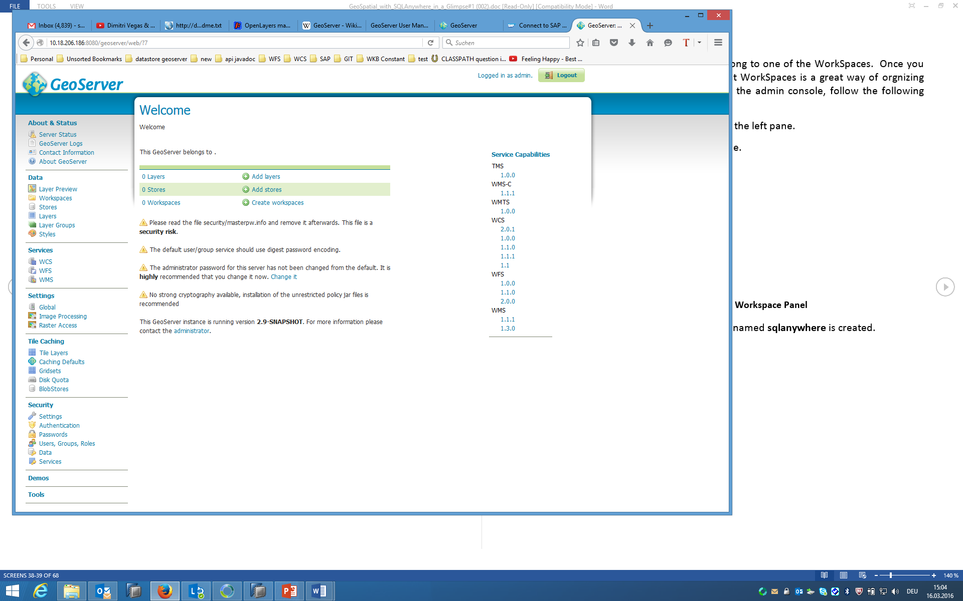

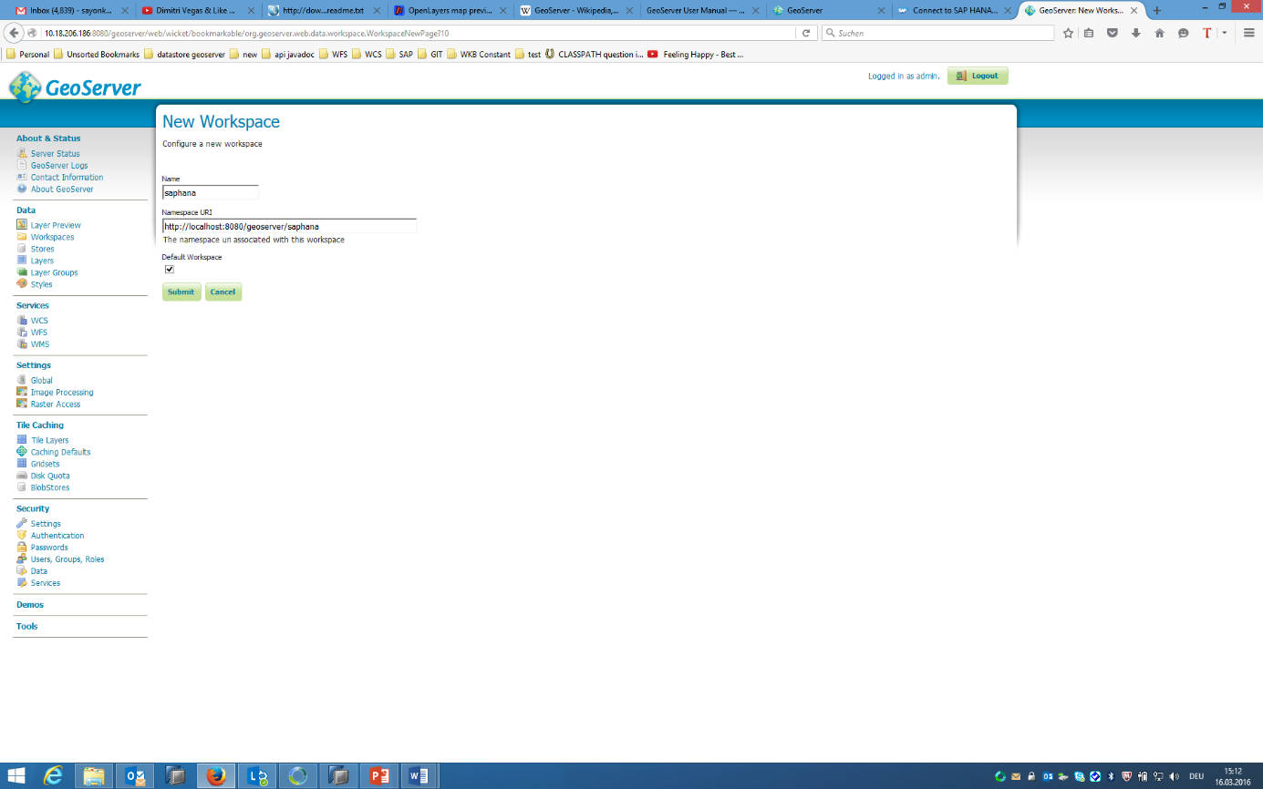**3 Creating a Workspace**

By GeoServer convention, all layers have to belong to one of the Workspace. Once you have lots of layers, grouping them into different Workpace is a great way of organizing your map server. To create a Workspace using the admin console, follow the following steps:

1. Click **Workspaces** link under **Data** category on the left pane.
2. Click **Add new workspace** link on the right pane.
3. Enter the following data then click **Submit.**
4. Once the above steps are done, a WorkSpace named **saphana** is created.

## 

**4 Creating a SAP HANA Data Store**

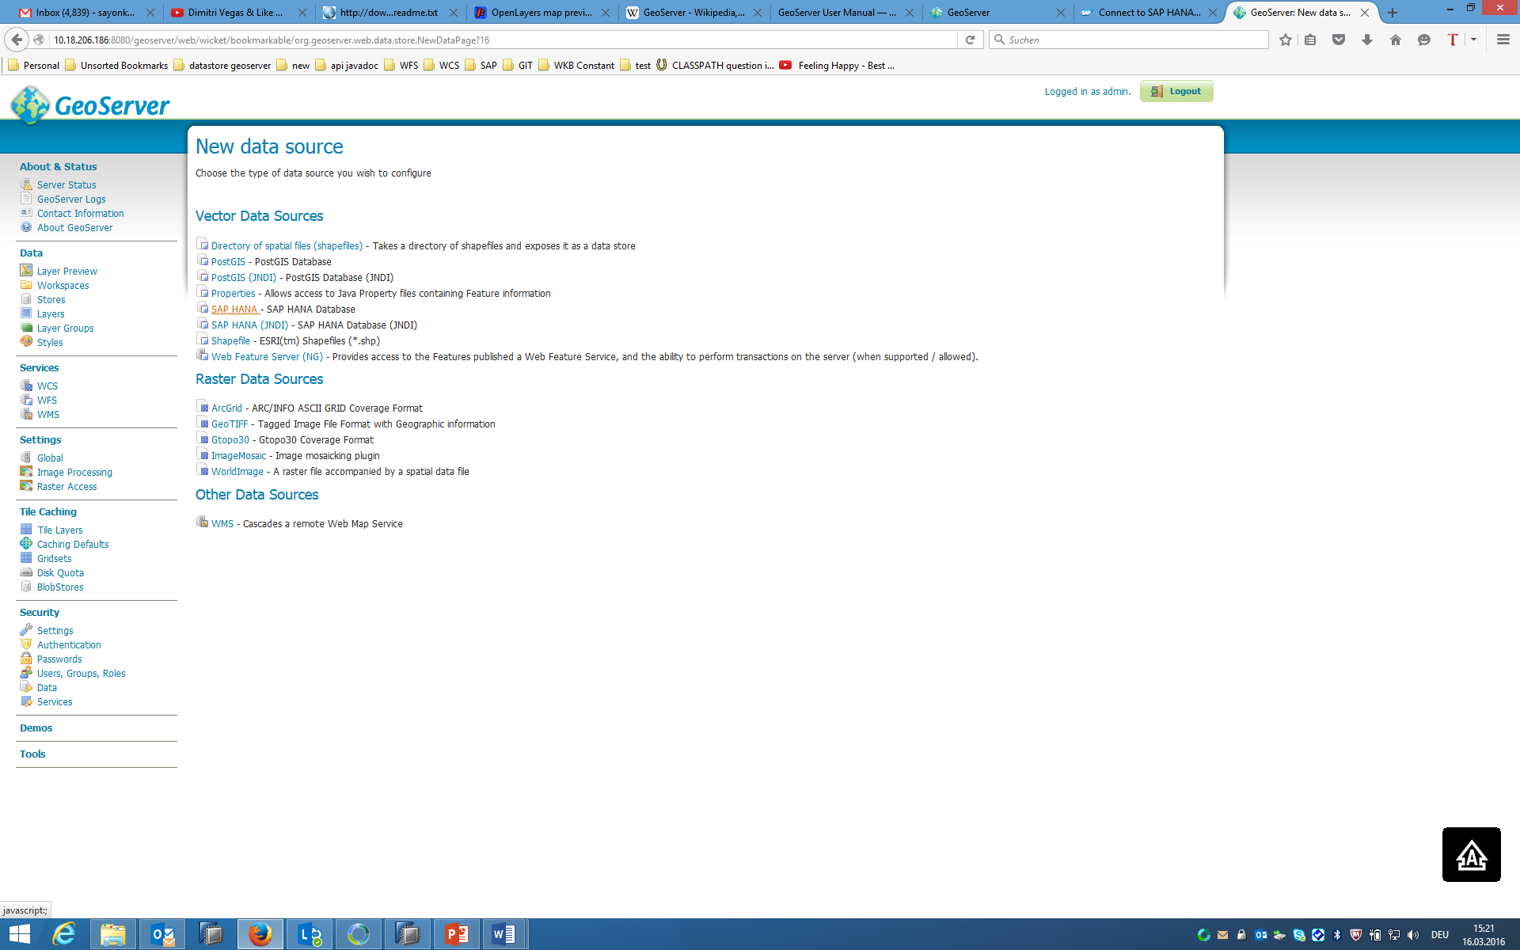To load data from SAP HANA database to GeoServer, we need to setup a Data Store for the SAP HANA connection. A Data Store defines connection parameters and connection pooling utilities. As such, a Data Store should be defined for each and every SAP HANA schema you are planning to use with GeoServer. To Create a SAP HANA Data Store, follow the following steps:

1. Click **Stores** link under **Data** category on the left pane.
2. Click **Add new Store** link on the right pane.
3. There are various different data sources available to GeoServer. Select **SAP HANA** under **Vector Data Sources** category.
4. Enter the following data then click **Submit.**

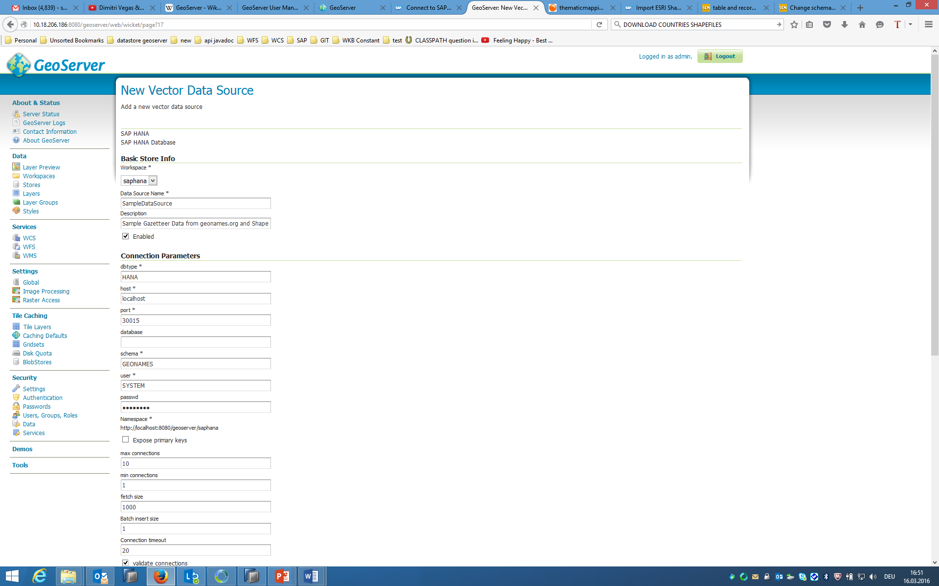

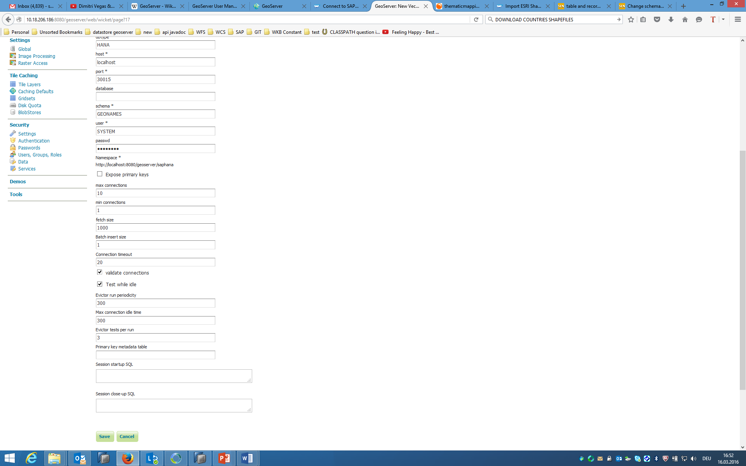

1. Once the above steps are done, a Data Store named **SampleDataSource** is created. The browser will be automatically redirected to Adding Layers.

**5 Setting up Layers and Layer Groups**

Follow the following steps to setup Layers and Layer Groups for this demo:

1. Click **Layers** link under **Data** category on the left pane.
2. Click **Add new resource** link on the right pane.
3. Select and click **saphana:sampledatasource** in the drop-down list. A list of all available layers within the data store will show shortly after.

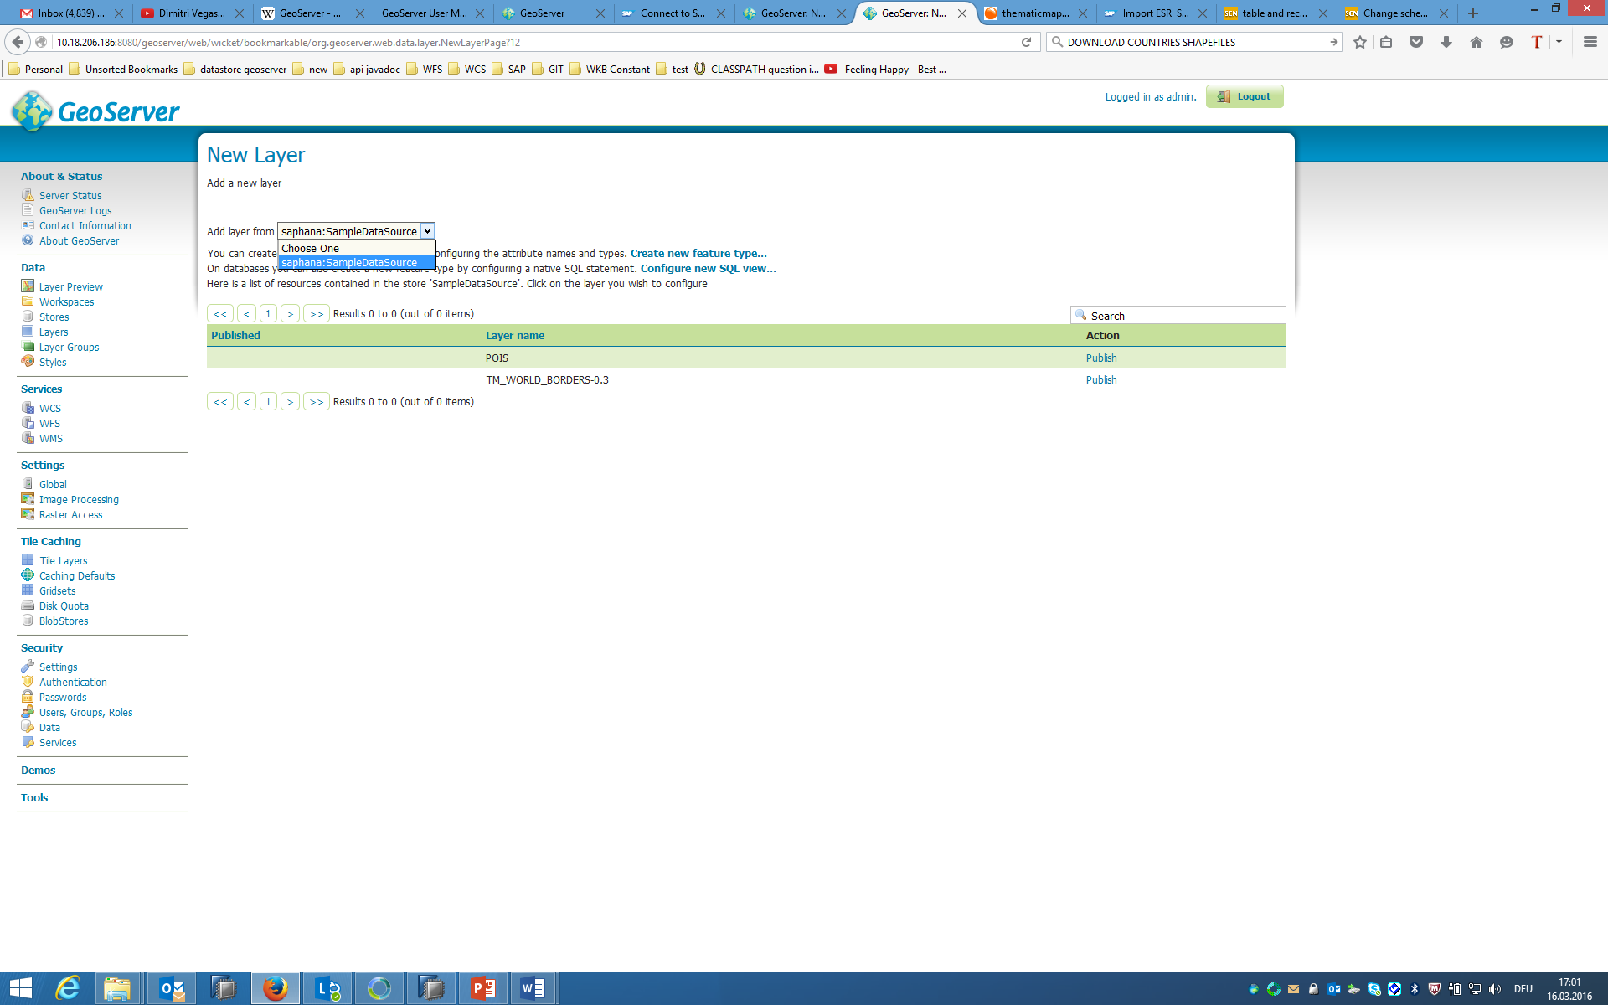

1. Click the **Publish** link for layer **POIS**.
2. You may now enter the properties for your layer. The only mandatory property missing is the Bounding Box property. You may either enter you custom value, or click **Compute from native bounds** link under the section **Lat/Lon Bounding Box** to let the SAP HANA Database do the calculation.

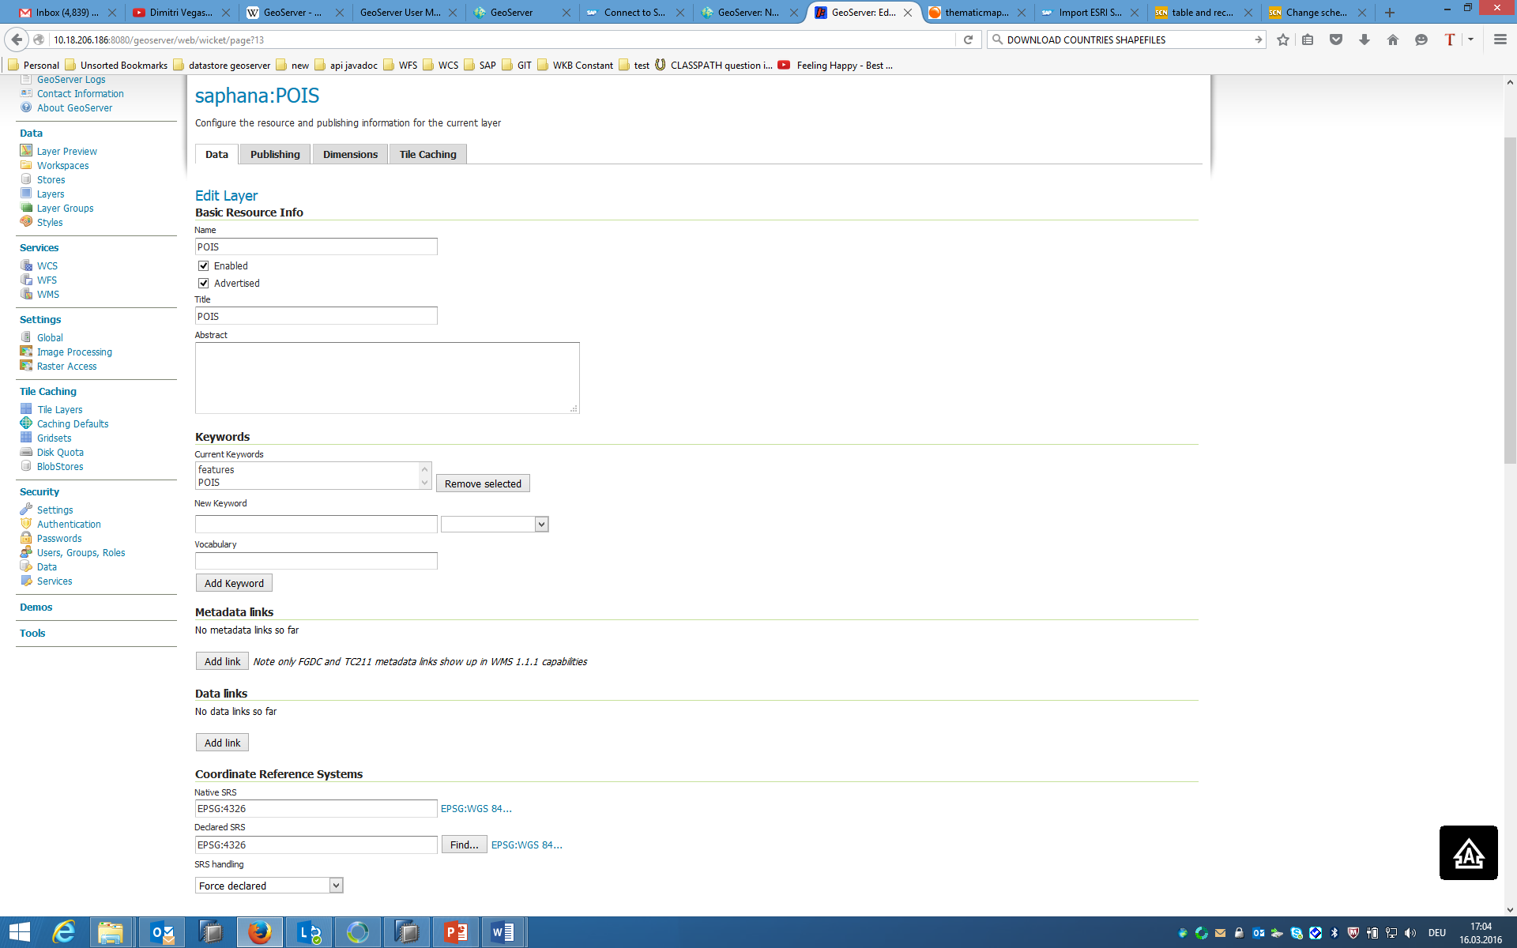

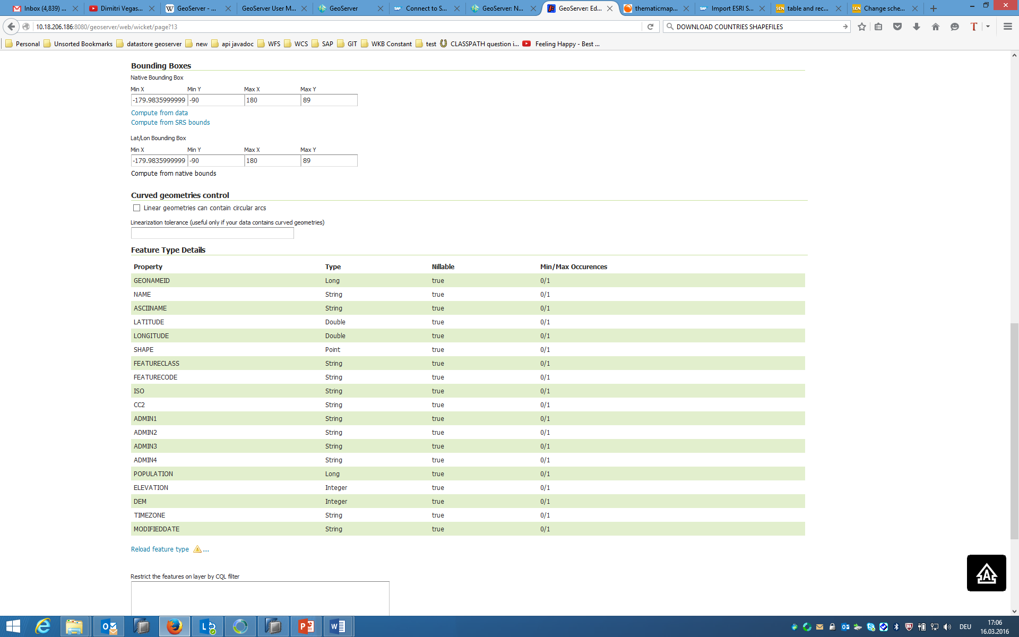

1. This data contains several point of interests. So you may go to the **Publishing** tab and choose the default style to be **points**.

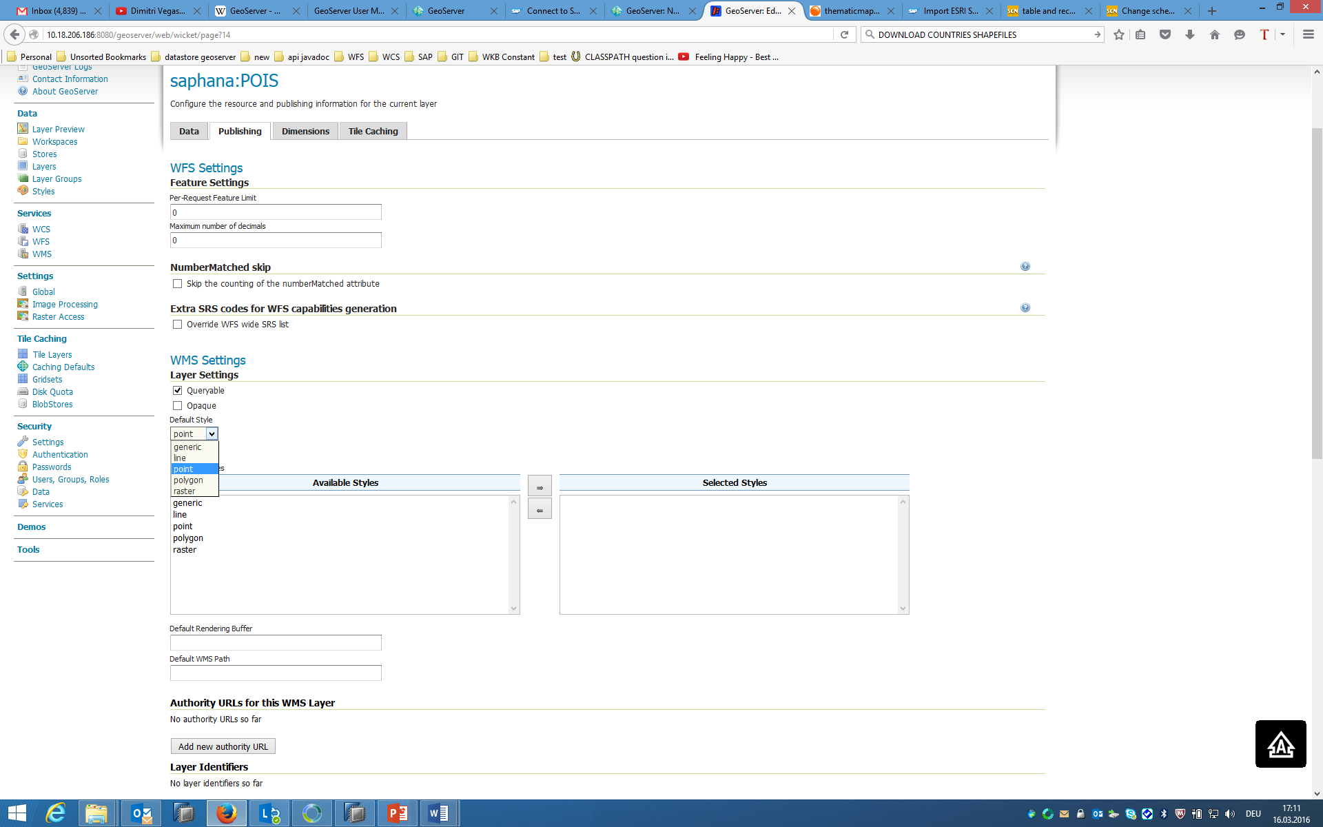

1. You are free to change any other attributes under tab **Data**, **Publishing**, or **Dimensions**. When you’re ready, click **Save**.
2. Once the above steps are done, the layer **POIS** is created. Repeat the above steps for layer **TM_WORLD_BORDERS-0.3** (make sure to choose the default style as polygon instead of points in the publishing).
3. Now we’ve done creating the layers, let’s create a layer group called **GroupedLayer_POISWorld** that combines layers **POIS** and **TM_WORLD_BORDERS-0.3**. Click **Layer Groups** on the left pane.
4. Click **Add new layer group** on the right pane.
5. Click **Add Layer…** link to add layers **POIS** and **TM_WORLD_BORDERS-0.3.**

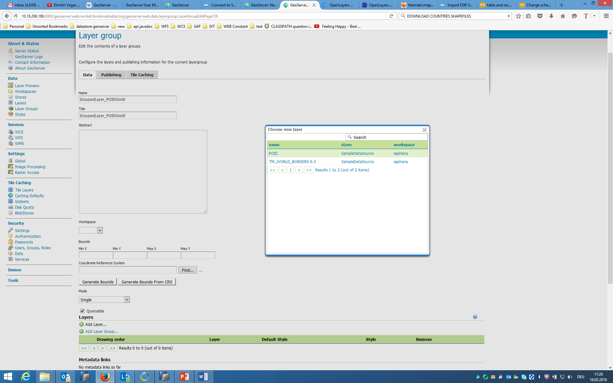

1. Click **Generate Bounds** button or enter custom values to generate a bounding box for the layer group.

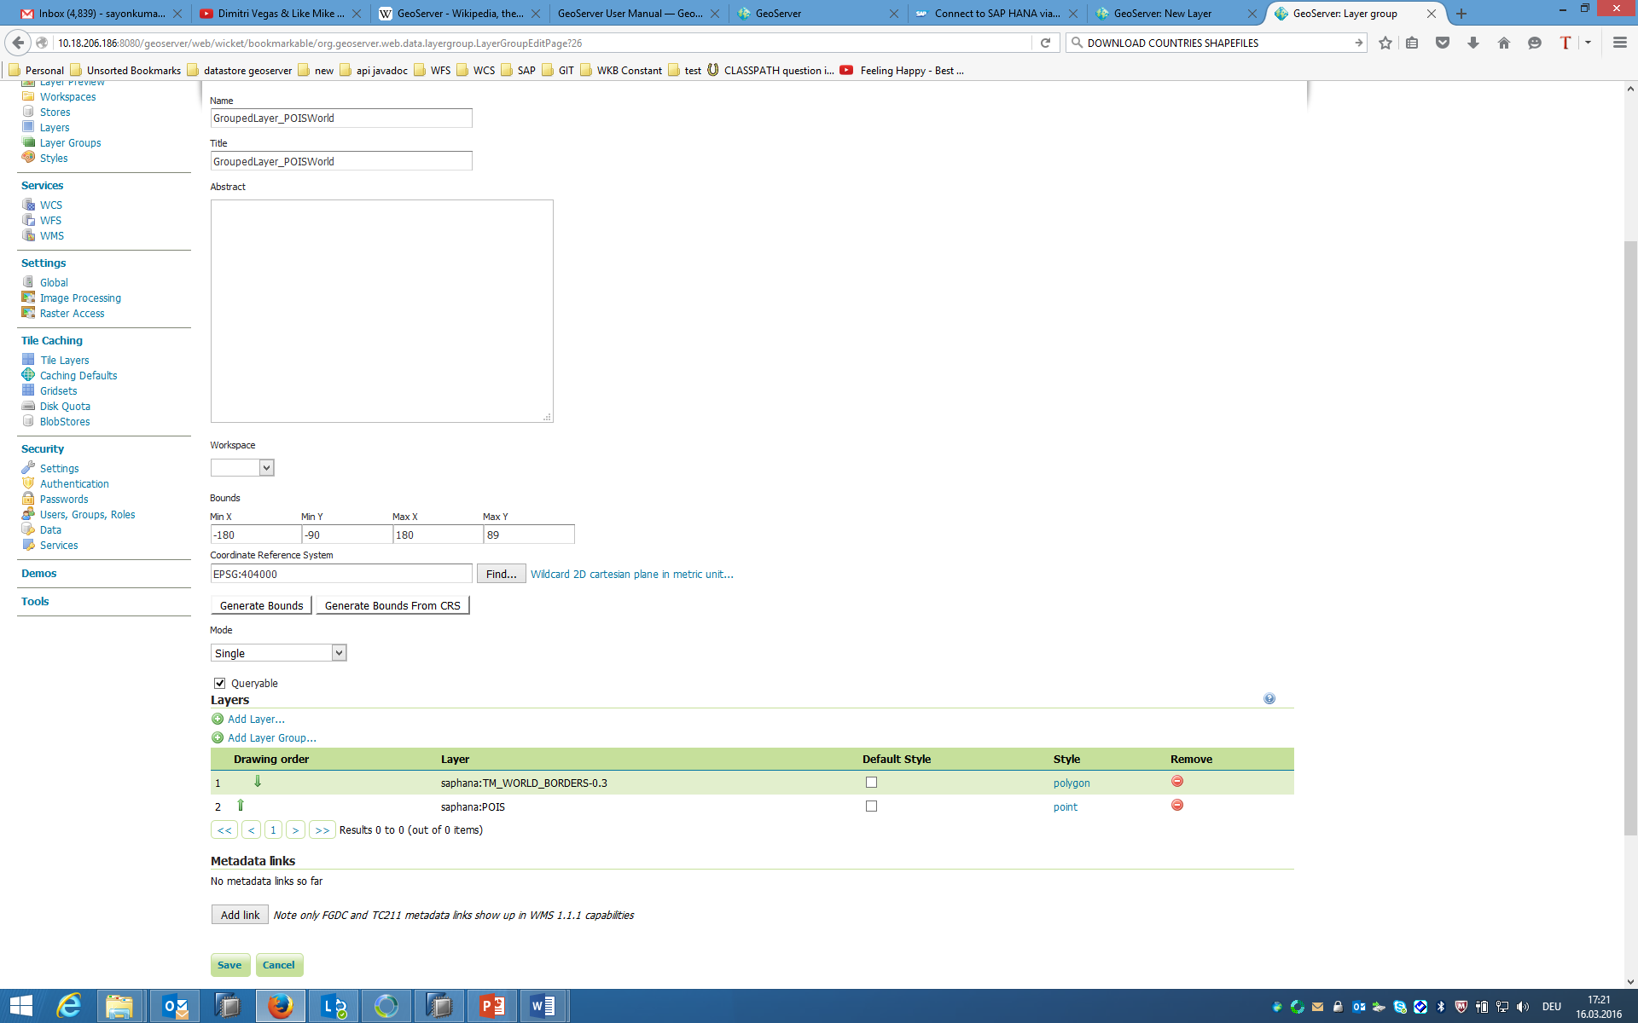

1. Click **Save** to generate the Layer Group **world**.

**6 Preview Maps in Open Layer**

Now we’ve done configuring the maps, we can preview them with OpenLayers without even have to write a html page. Simply follow the following steps:

1. Click **Layer Preview** link under **Data** category on the left pane.

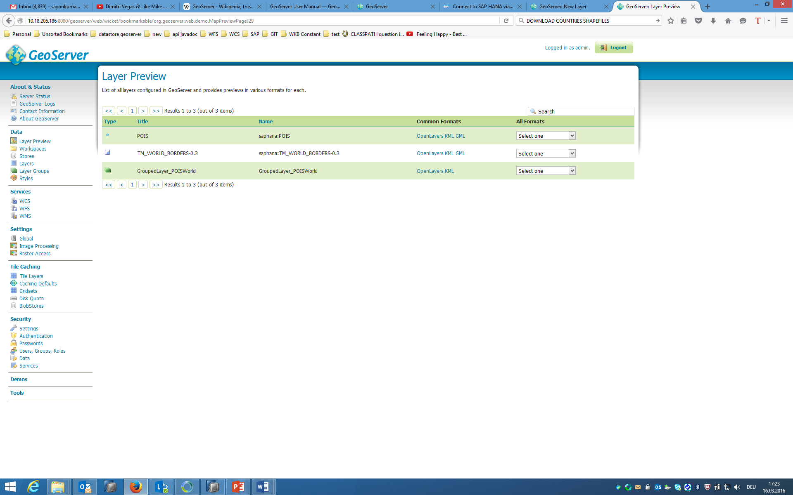

1. Click **OpenLayers** link under **Common Formats** column for each of the layers or layer groups you wish to preview. Below are the maps you are expected to see in the previews.

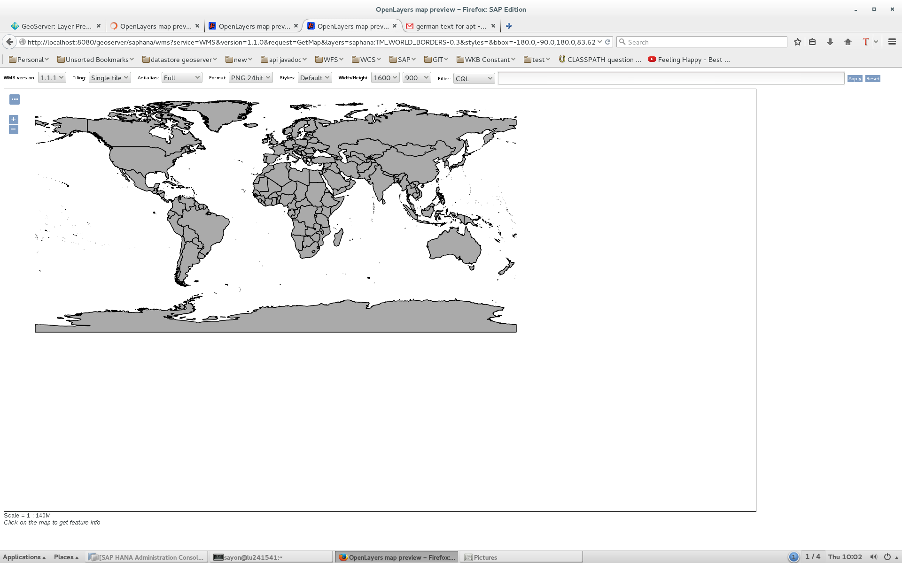

*Layer: saphana:TM_WORLD_BORDERS-0.3*

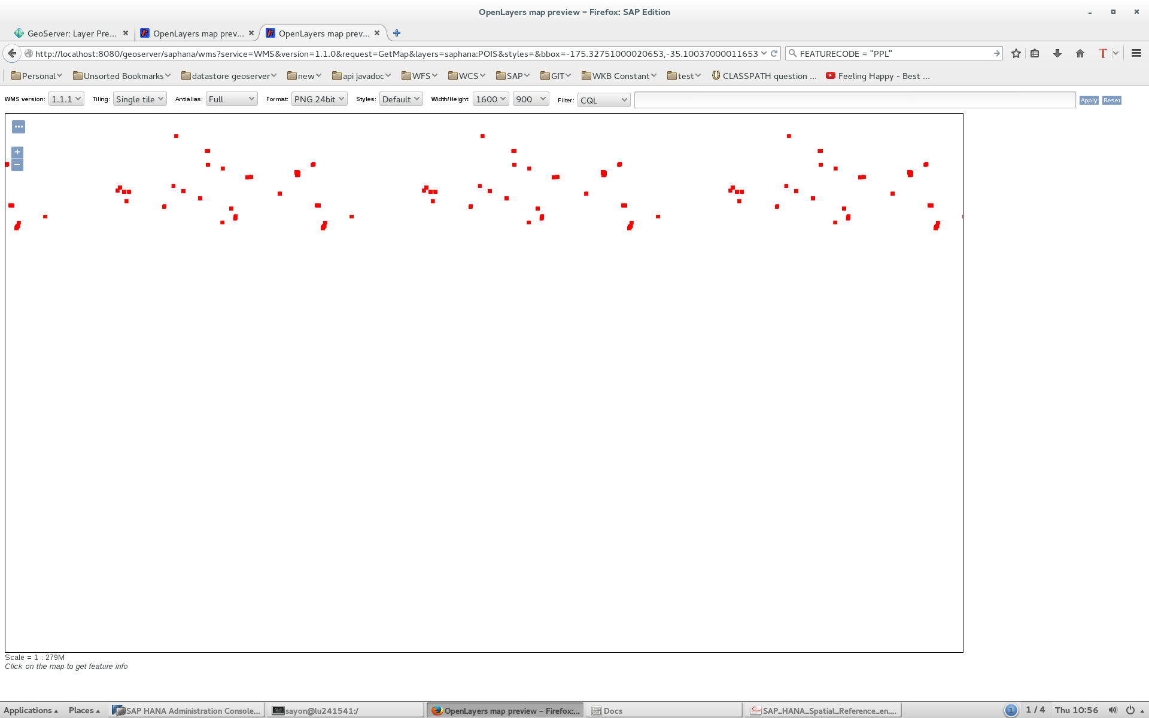

*Layer: saphana:POIS*

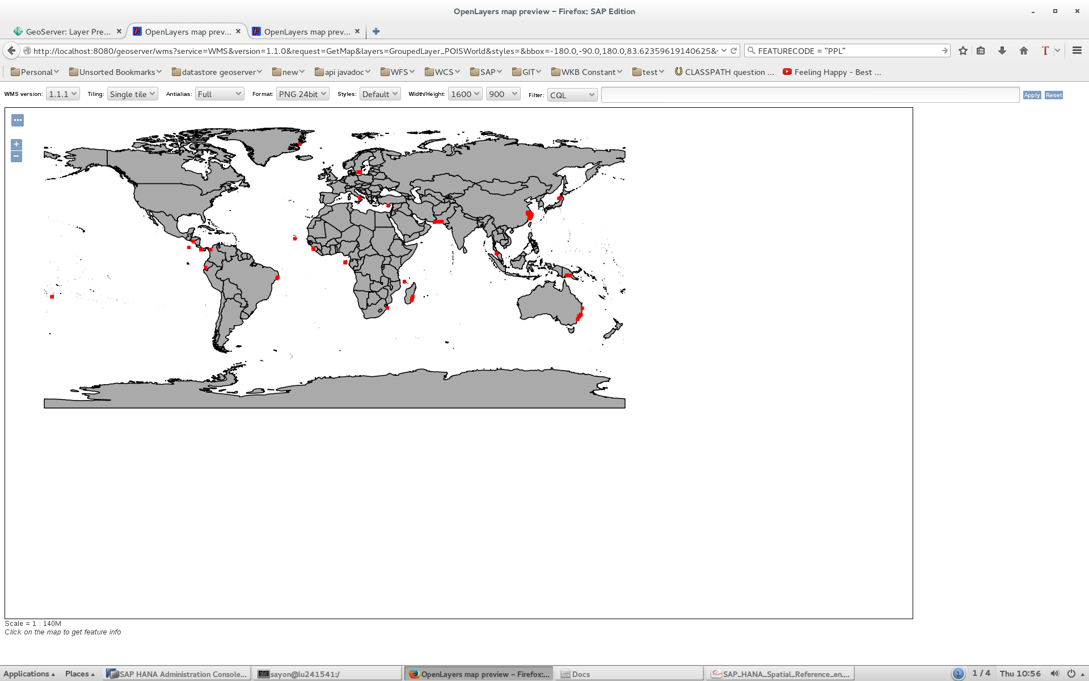

*Layer: GroupedLayer_POISWorld*

1. 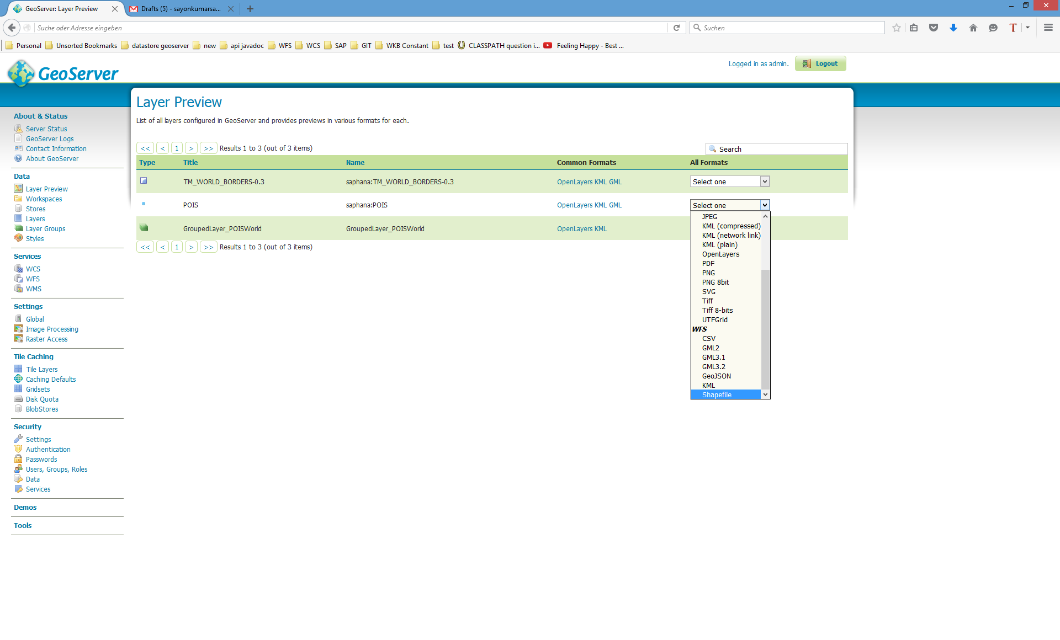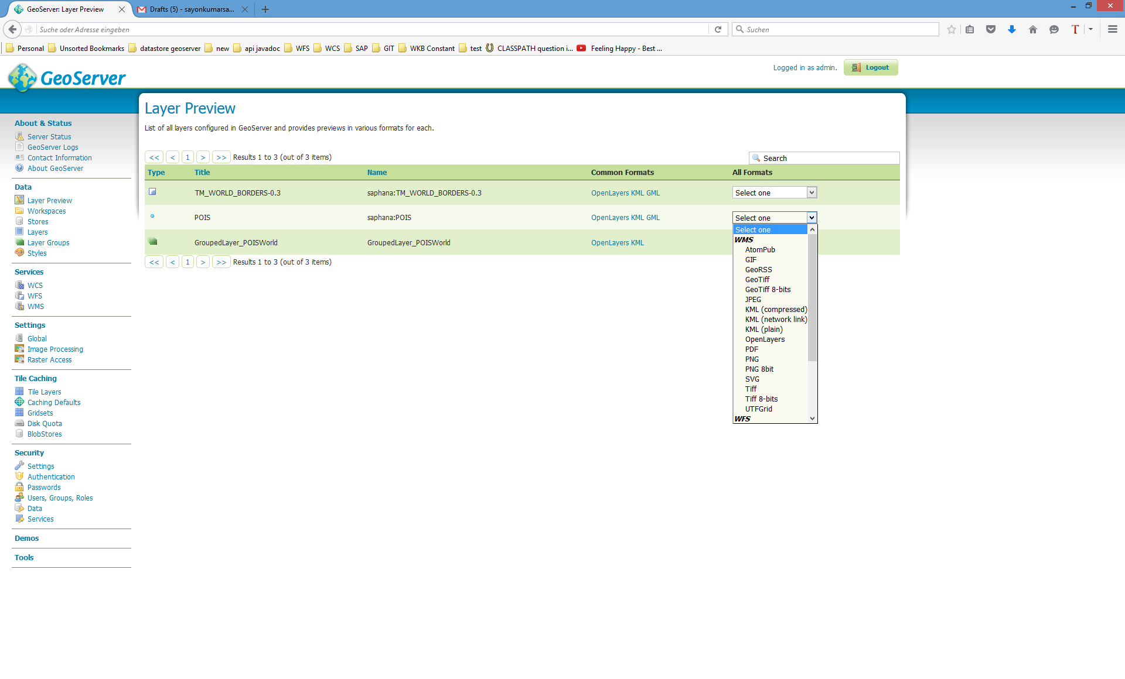You can also get a lot of various **other formats** for the layers by choosing from the drop-down menu.

**7 CQL: Common Query Language in GeoServer**

CQL (Common Query Language) is a query language created by the OGC for the Catalogue Web Services specification. Unlike the XML-based Filter Encoding language, CQL is written using a familiar text-based syntax. It is thus more readable and better-suited for manual authoring. However, CQL has some limitations. For example it cannot encode id filters, and it requires an attribute to be on the left side of any comparison operator. For this reason, GeoServer provides an extended version of CQL called ECQL. ECQL removes the limitations of CQL, providing a more flexible language with stronger similarities with SQL.

To run a CQL on GeoSever, follow the following steps:

1. Click **Layer Preview** link under **Data** category on the left pane.
2. Click **OpenLayers** link under **Common Formats** column for the layer **saphana:TM_WORLD_BORDERS-0.3.**

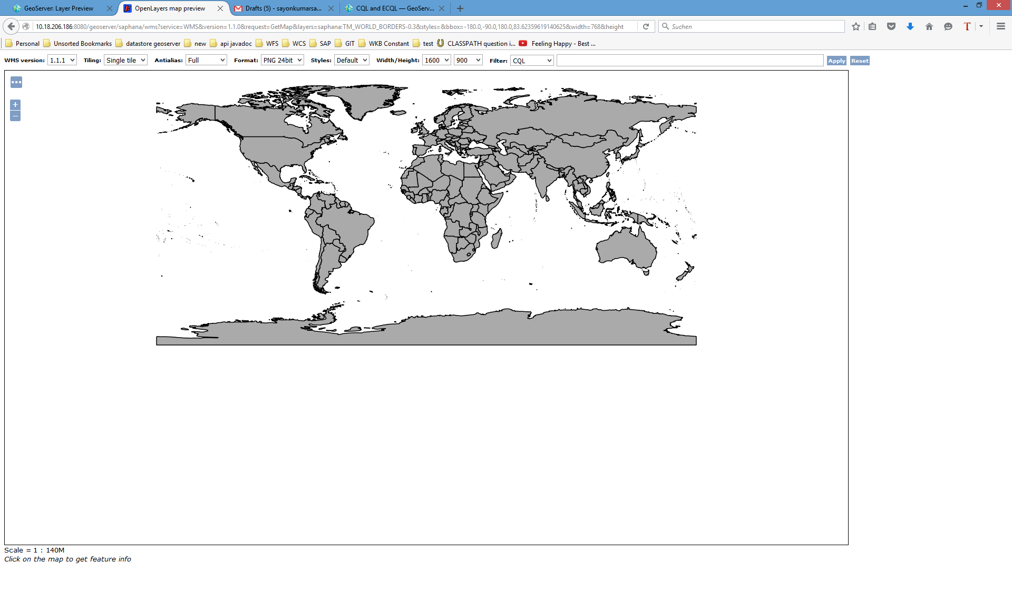

1. Type the CQL: **POP2005>50000000** in the CQL Filter text bar and click on **Apply**.

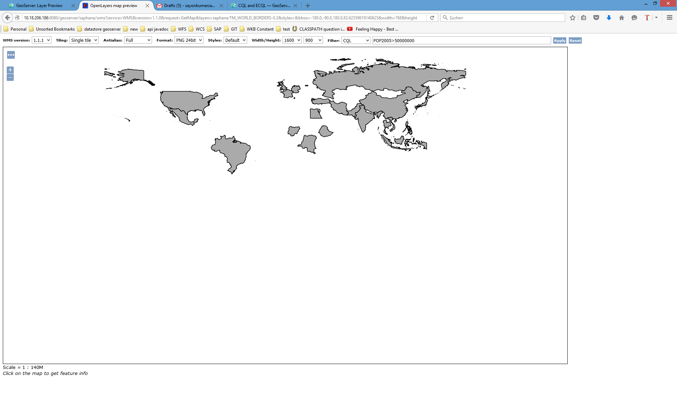

The result above displays only the shapes whose corresponding column POP2005 (population in 2005) is greater than 50000000.

1. Type the CQL:

**INTERSECTS (SHAPE, POLYGON ((-5.8447265625 58.990712823253894,-8.6572265625 57.62886104052531,-7.119140625 55.944201366556634,-5.5810546875 55.09840898289597,-4.833984375 54.10570980429925,-5.2734375 52.61097025175982,-6.064453125 51.503186376638034,-6.2841796875 50.255546950930764,-6.26220703125 49.761308205624985,-5.185546875 49.604925493619184,-2.28515625 50.08666612902115,0.3955078125 50.479793575061706,1.1865234375 50.814178573614775,2.6806640625 51.775912838347296,2.4169921875 53.03584579937114,-0.52734375 56.578775474047085,-1.318359375 57.95676742951274,-2.021484375 58.92272697910158,-2.109375 59.64102901358082,-3.8232421875 59.50750021119756,-5.8447265625 58.990712823253894)))**

in the CQL Filter text bar and click on **Apply**.

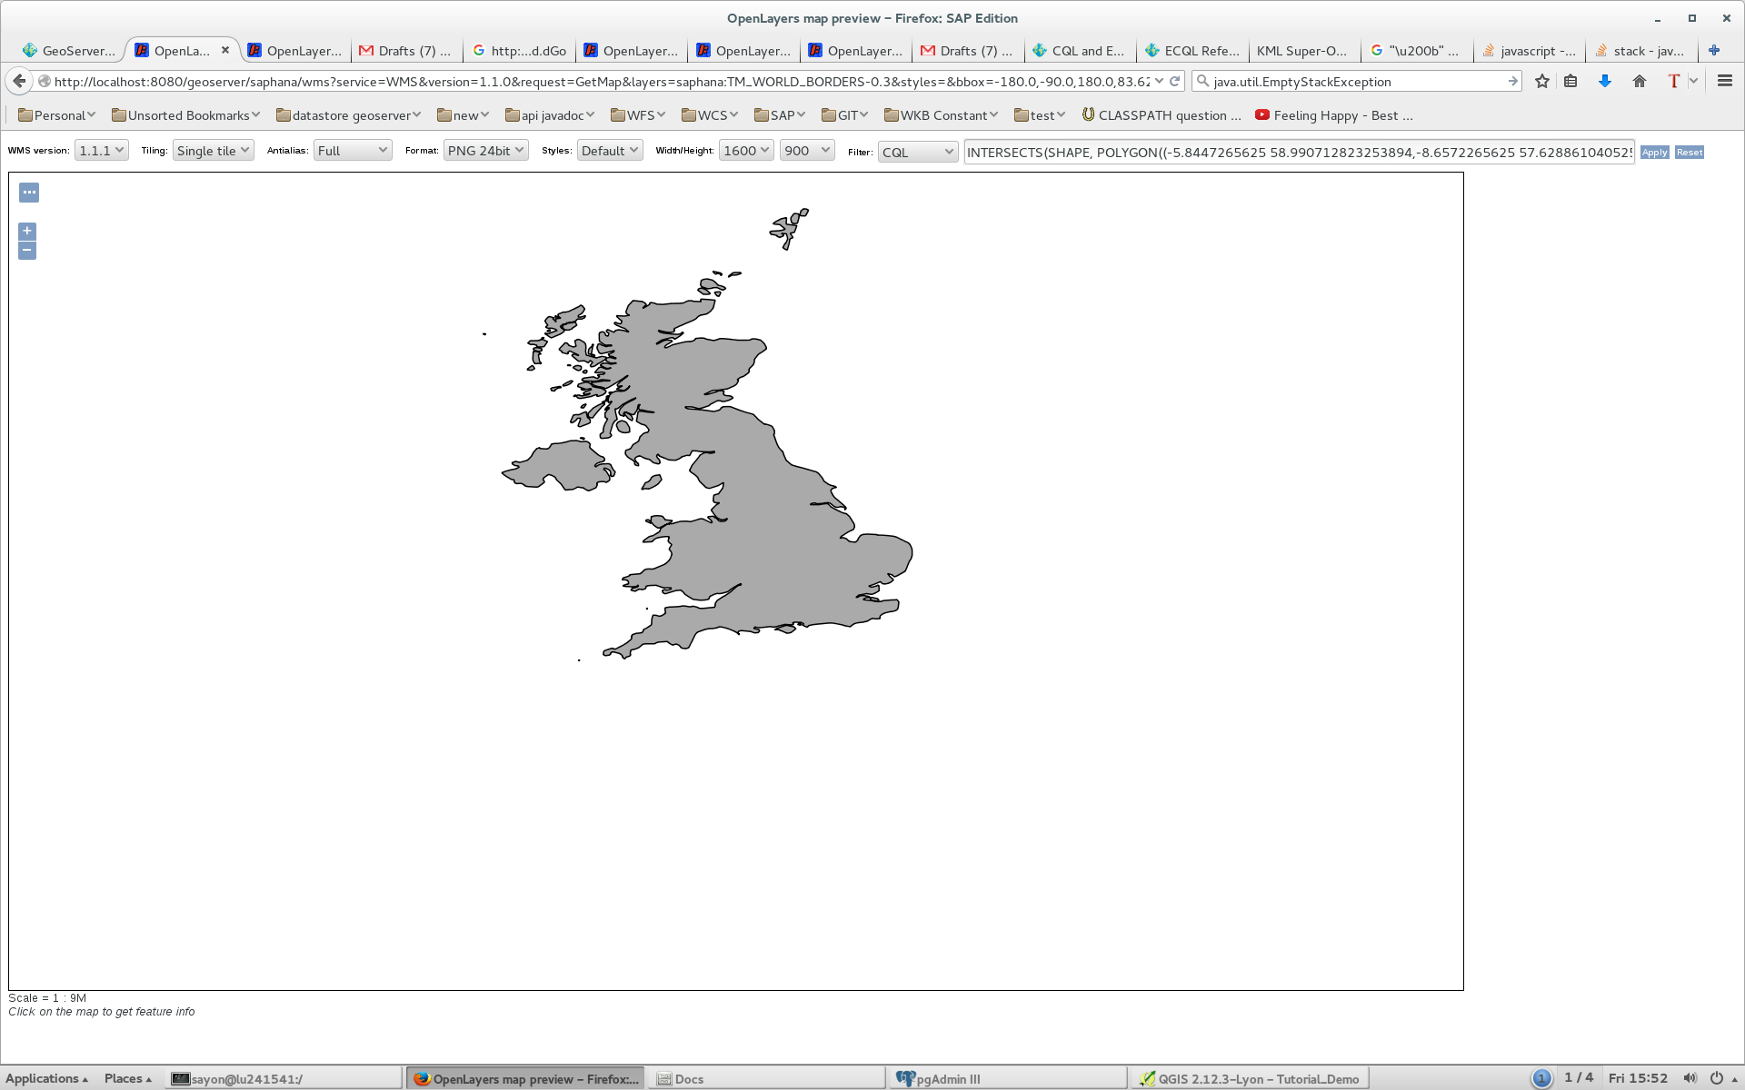

The result above displays the intersection between all the shapes and the polygon representing United Kingdom.

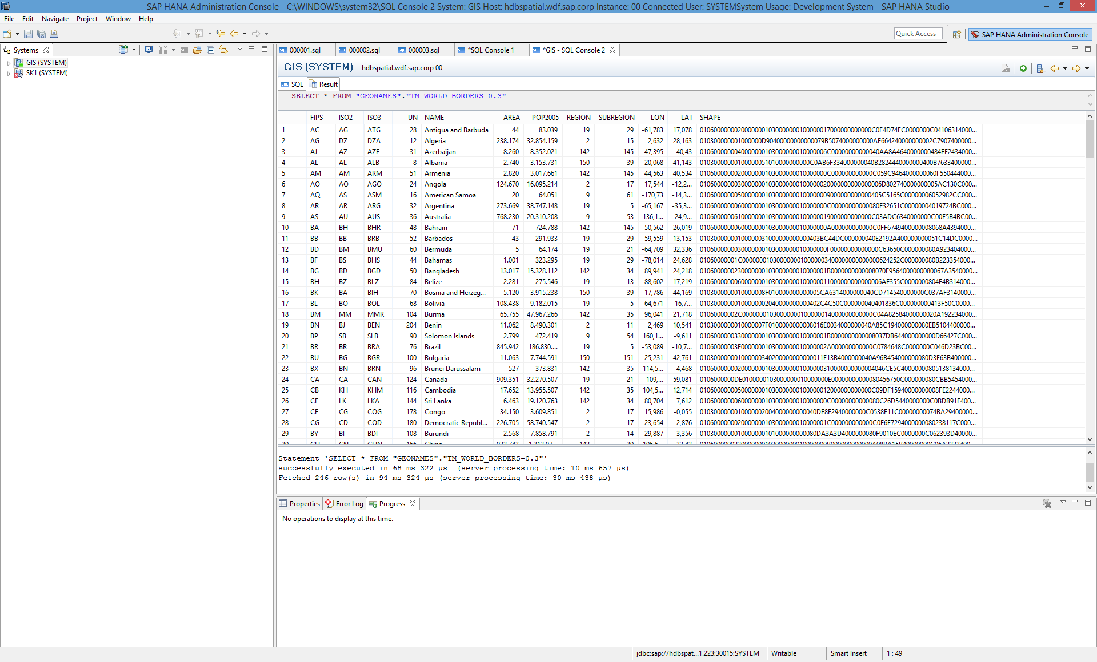

*Above is the actual data on which the two CQL queries are run.*

**8 Customizing Layer Styles**

GeoServer uses a symbology system called Styled Layer Descriptor (SLD), which is a XML based file. To add/edit a style for a layer, follow the following steps:

1. 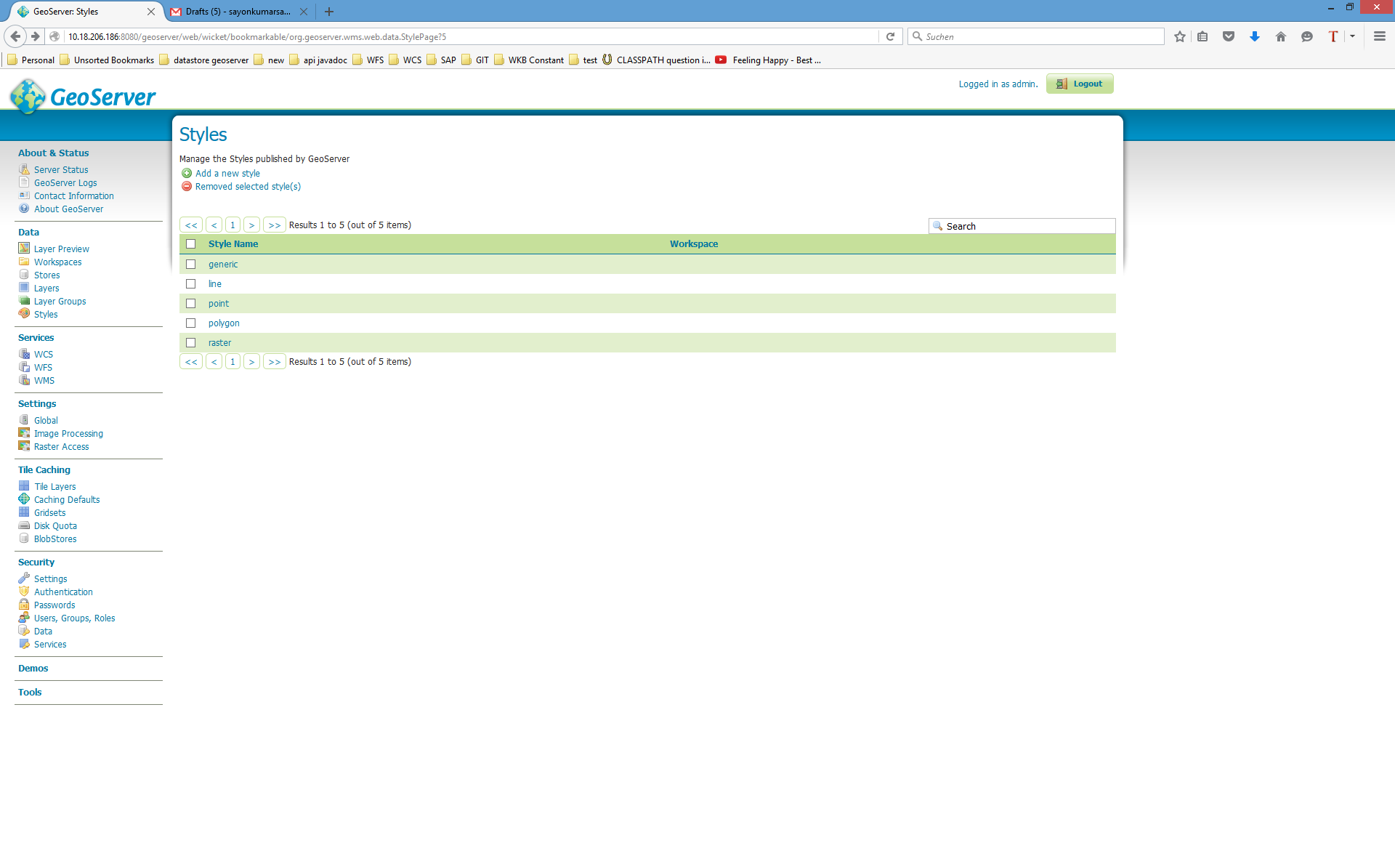Click **Styles** on the left pane
2. 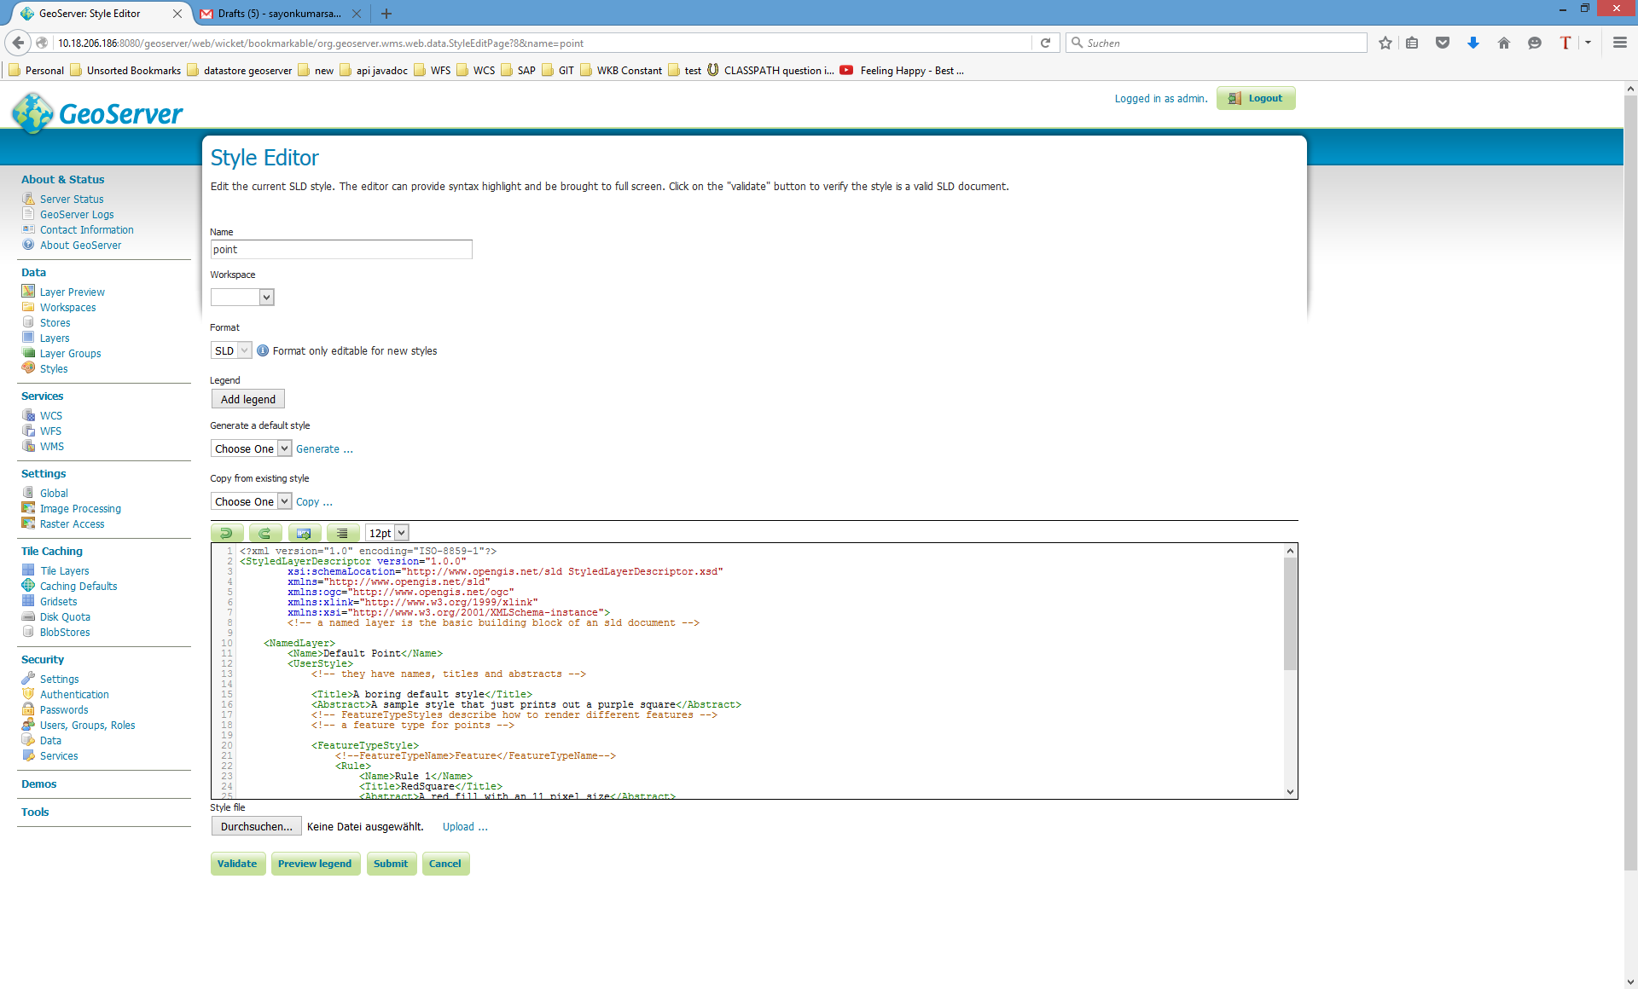Click **Add a new style** link on the right pane, or click on an existing layer from the list to open the **Style Editor**.

However, instead of writing this SLD file by hand, we can use uDig (user-friendly Desktop Internet GIS) to create the file. Follow the steps in the **Section** **13** **WFS & Layer Styling in UDig for GeoServer** explained later**,** to create custom styles with uDig.

**9 Create new SQL View in GeoServer**

GeoServer lets you create a new view by configuring a native SQL statement by the following steps:

1. Click **Layers** link under **Data** category on the left pane.
2. Click **Add new layer** link on the right pane.
3. Select and click **saphana:SampleDataSource** in the drop-down list.
4. 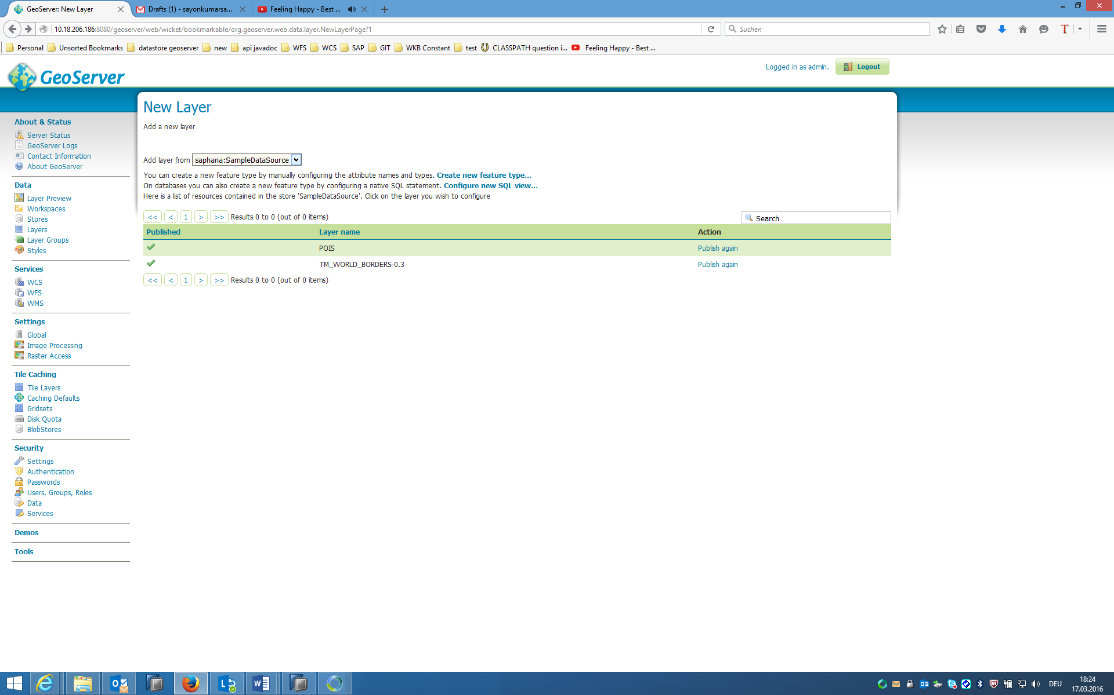Click the link **Create new SQL View…** under the drop-down button to create a new layer.
5. 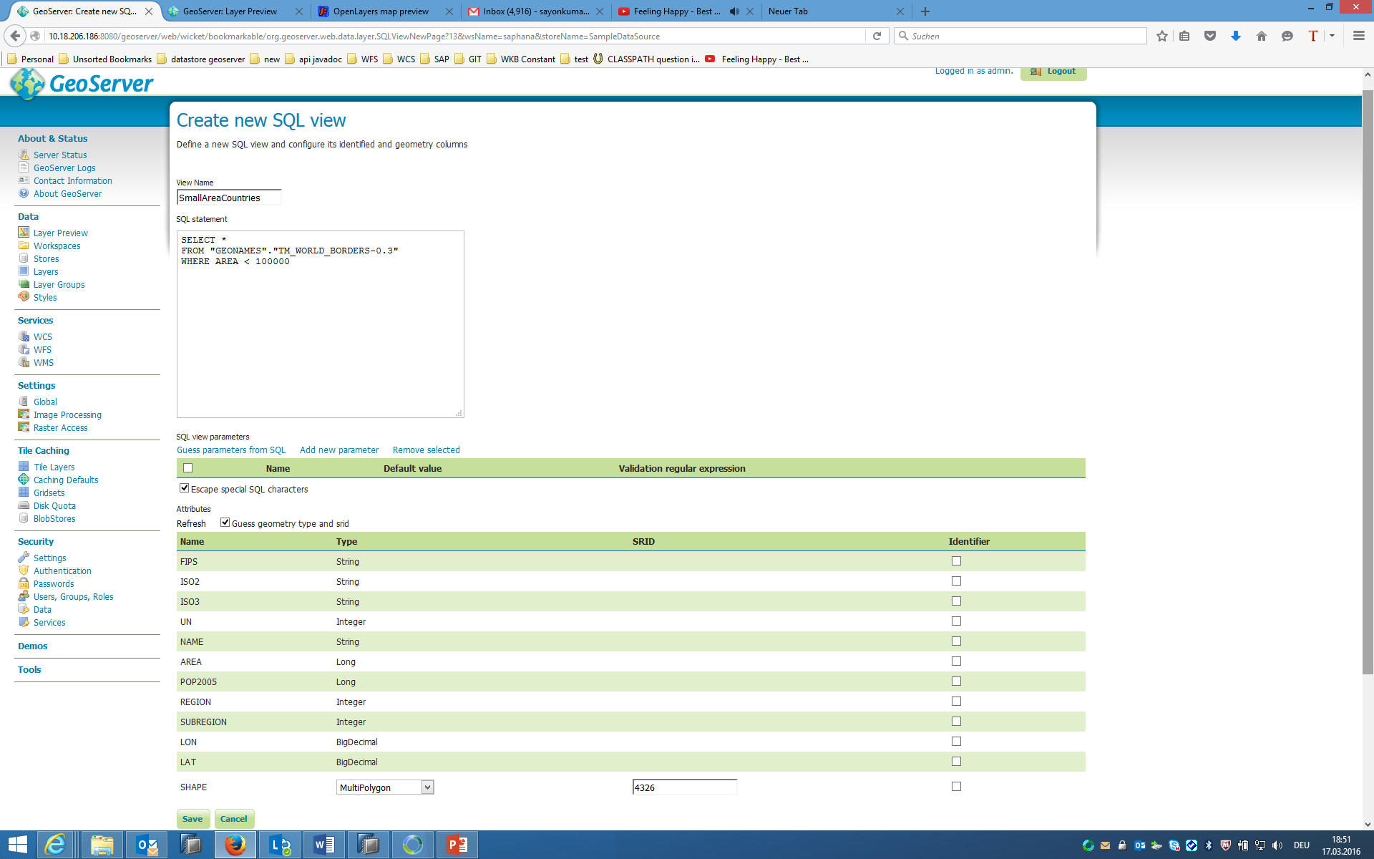Type the View Name to be **SmallAreaCountries**
6. Type the following SQL statement:  
   **SELECT *   
   FROM "GEONAMES"."TM_WORLD_BORDERS-0.3"  
   WHERE AREA < 100000**
7. Click on **Refresh Attributes** to generate the attribute list from the SQL statement
8. On clicking **Save**, the browser will prompt you to edit the layer you just created. You may either enter you custom value, or click **Compute from native bounds** link under the section **Lat/Lon Bounding Box** to let the SAP HANA Database do the calculation. Then click **Save**. The layer will become accessible shortly after this step.
9. Click **Layer Preview** link under **Data** category on the left pane.
10. 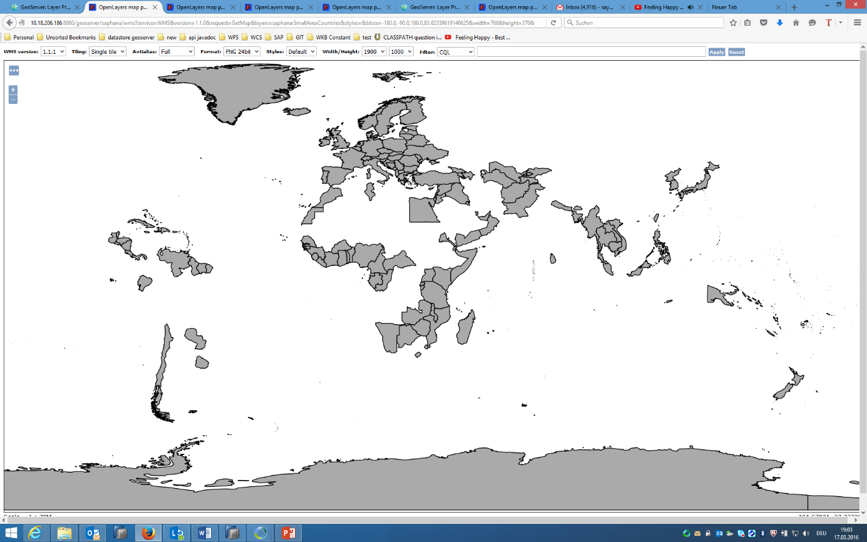Click **OpenLayers** link under **Common Formats** column for the layer **saphana:SmallAreaCountries.**

Note: In this case, it is just a view and no table called **SmallAreaCountries** is actually created in SAP HANA.

**10 Create new Feature Type (spatial table) SAP HANA using GeoServer**

GeoServer lets you create a new empty layer by the the following steps:

1. Click **Layers** link under **Data** category on the left pane.
2. Click **Add new layer** link on the right pane.
3. Select and click **saphana:SampleDataSource** in the drop-down list.
4. Click the link **Create new feature type…** under the drop-down button to create a new layer.



1. For the purpose of this demo, we’re making a simple table with a single Polygon geometry column, click **Add new attribute** link to add the column.
2. Enter the following data then click **Save**. Note: The SRID you enter from the list in GeoServer must be installed in the SAP HANA database.

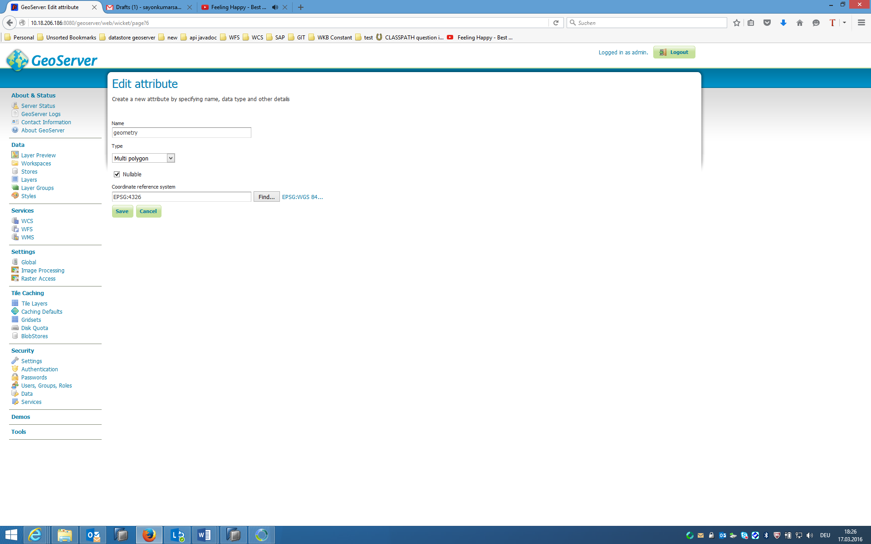

1. Enter the name **DemoSpatialTable** for the layer, then click **Save**.

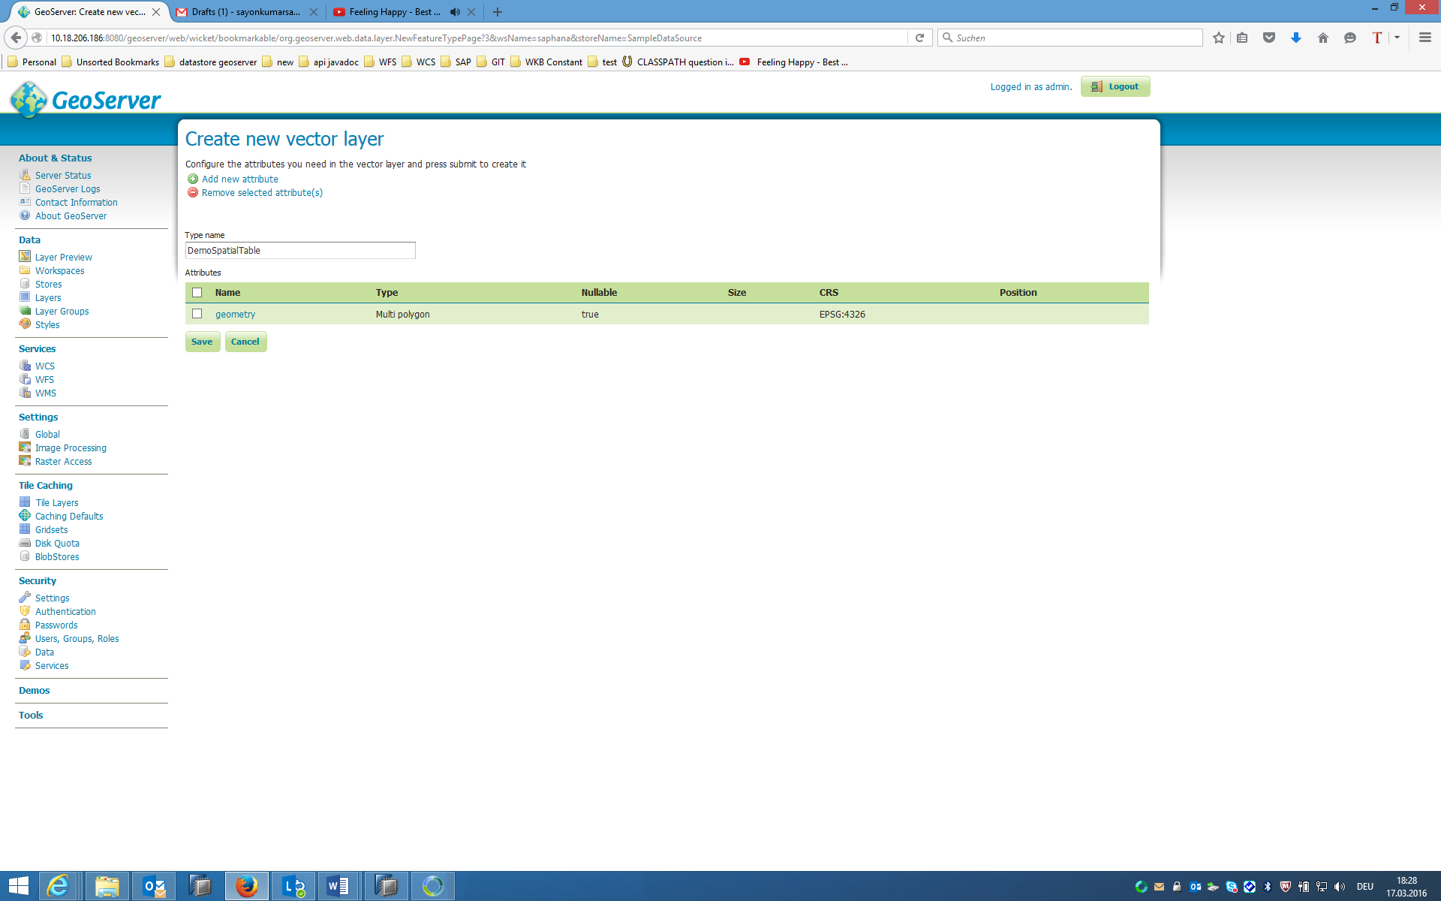

1. The browser will prompt you to edit the layer you just created. Manually enter the **Lat/Lon Bounding Box** [-180,-90,180,90], then click **Save**. The layer will become accessible shortly after this step. The table that is created in SAP HANA is as follows:

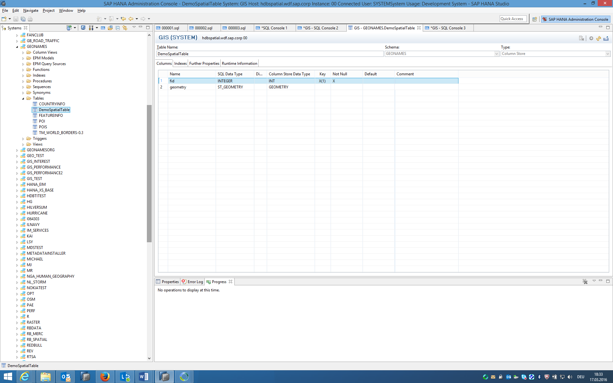

**11 OGC Standardized Services: WFS, WCS, WMS**

* WMS (Web Map Service): Protocol for serving geo-referenced map images which a map server generates using data from a GIS database.
* WFS (Web Feature Service): Provides an interface allowing requests for geographical features across the web using platform-independent calls.
* WCS (Web Map Service): Defines Web-based retrieval of coverages – that is, digital geospatial information representing space/time-varying phenomena.

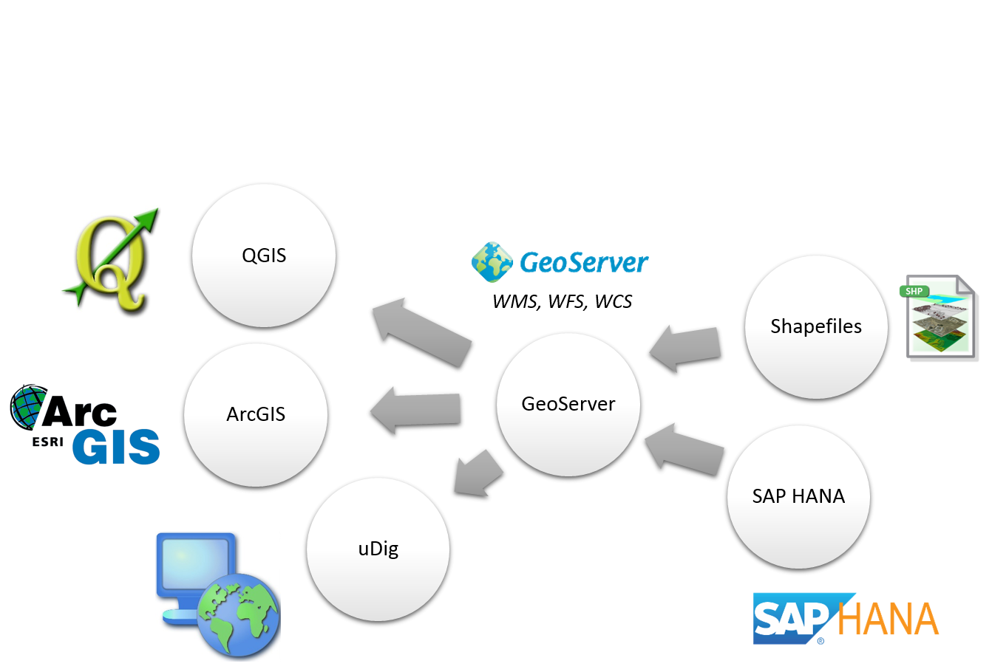

* WMS portrays spatial data to return static maps (rendered as pictures by the server).
* WFS and WCS provides:
  + Provides available data together with their detailed descriptions;
  + Defines a rich syntax for requests against these data;
  + Returns data with its original semantics (instead of pictures) which may be interpreted, extrapolated, etc., and not just portrayed.
* WFS layers are preferable over WMS layers if you need direct access to the attributes and geometries of the layers. However, considering the amount of data that needs to be downloaded (which leads to speed problems) it’s not always possible to use a WFS instead of a WMS.

**12 QGIS consuming Web Feature Service from GeoServer using data from SAP HANA**

**QGIS** is a cross-platform free and open-source desktop GIS application that provides data viewing, editing, and analysis. In this Demo, we will see how WFS is consumed by QGIS from GeoServer that uses the data from SAP HANA, and how the data can be queried.



1. Download and install **QGIS** from https://www.qgis.org/en/site/forusers/download.html
2. Click **Workspaces** link under **Data** category on the left pane of **GeoServer** and click on **saphana**. Check the services on the right and click on **Save**.

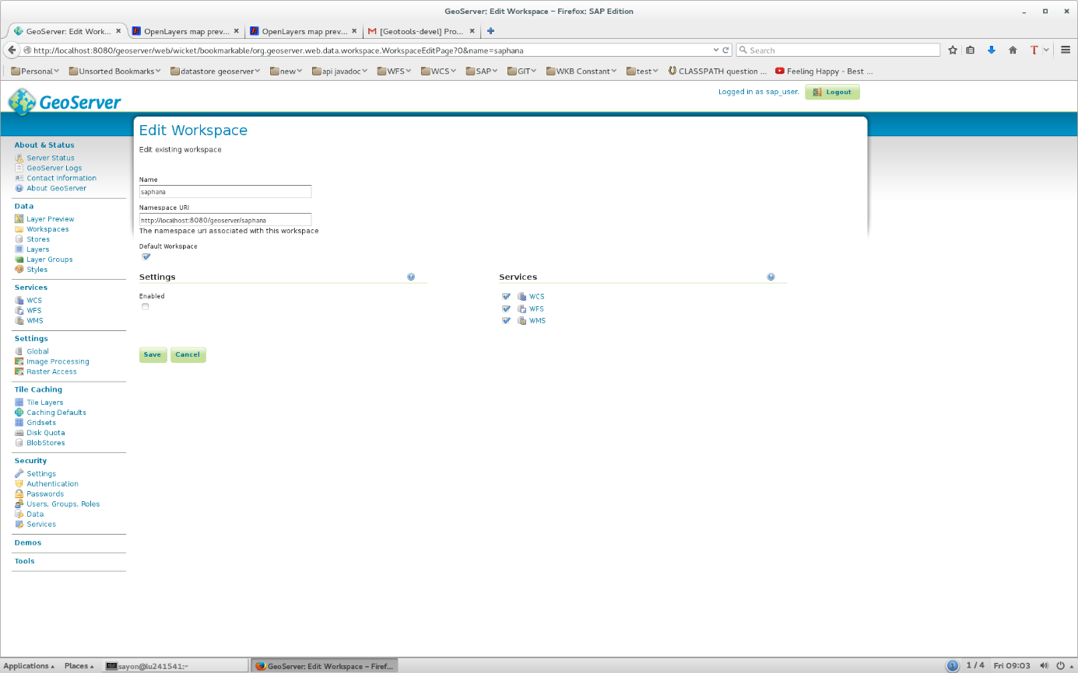

1. Start QGIS. Click on **Layer**->**Add …** and select **WFS** in the menu.
2. Now there needs to be a new connection made with GeoServer. Click on **New.**
3. Enter the following data for the connection and click on **OK**.

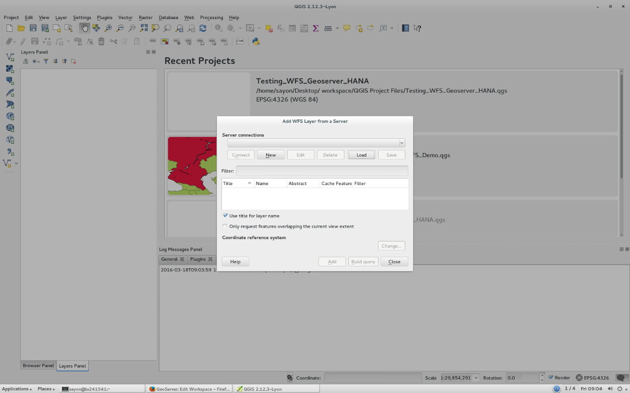

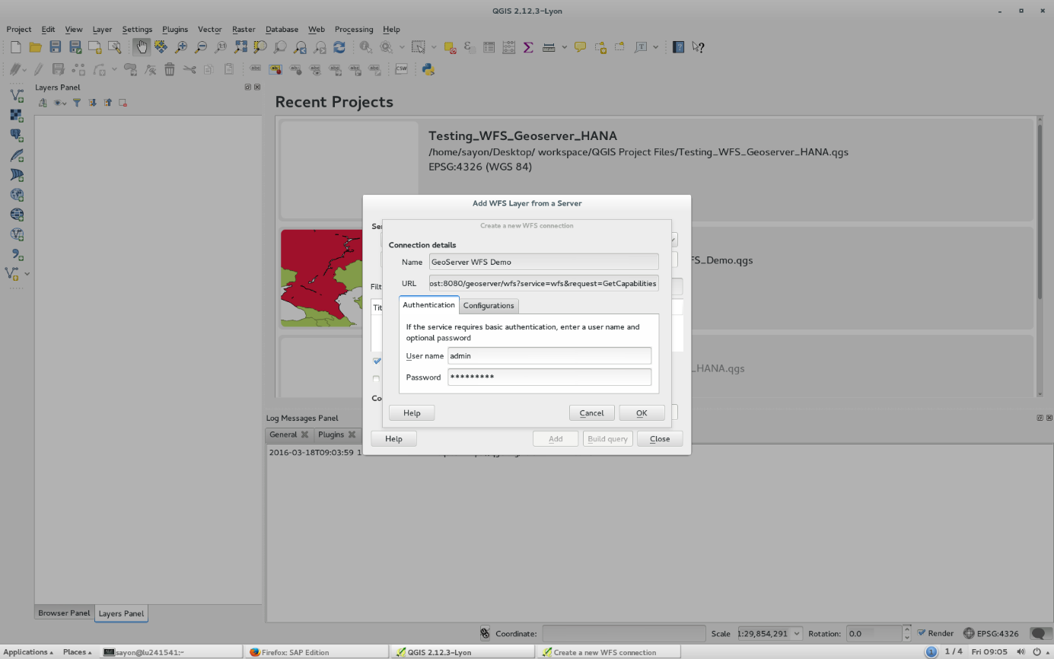

1. 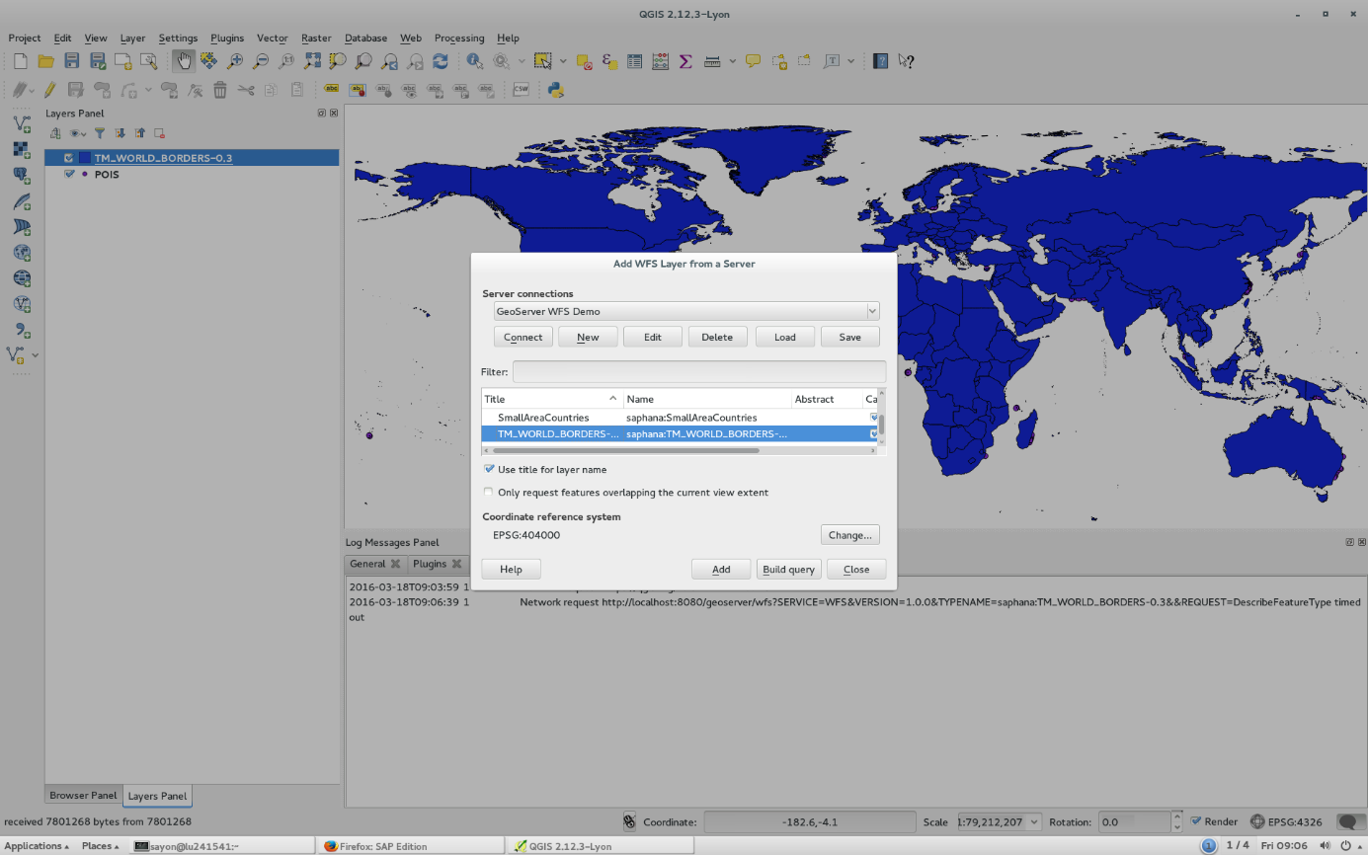The list of layers from GeoSever will be displayed as follows. Select the Layers **POIS** and **TM_WORLD_BORDERS-0.3**. Then Click on **Add.**

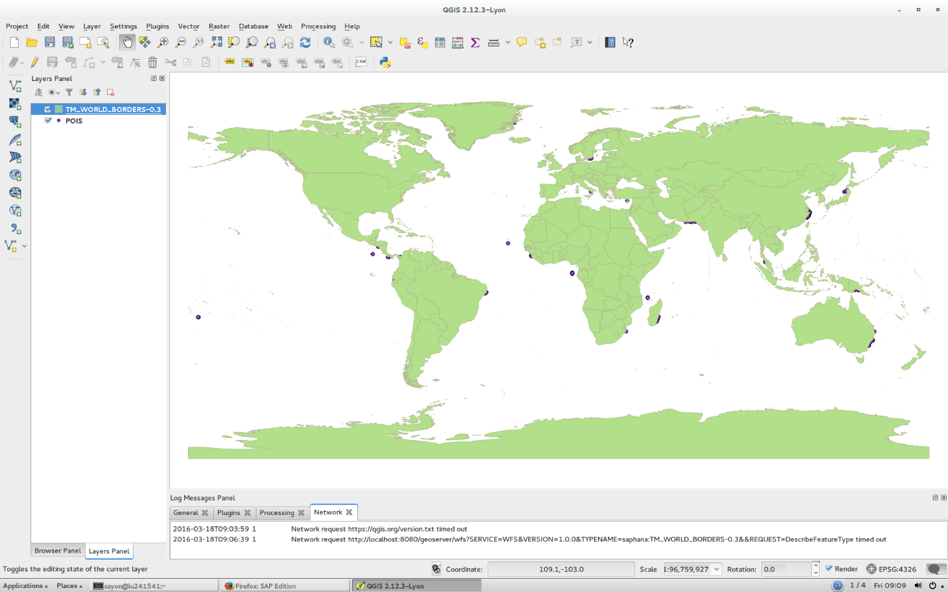 The output of the map looks like below.

1. Instead of adding a layer directly, queries can be built before adding. Again click on **Layer**->**Add …** and select **WFS** in the menu.
2. Select the Layer **TM_WORLD_BORDERS-0.3** like in **Step 6**. Then Click on **Build Query**.
3. On the right, choose **AREA** from the drop down menu of **Fields and Values**. On the left text box., type **> 100000** beside **‘AREA’**. Click on **OK**.

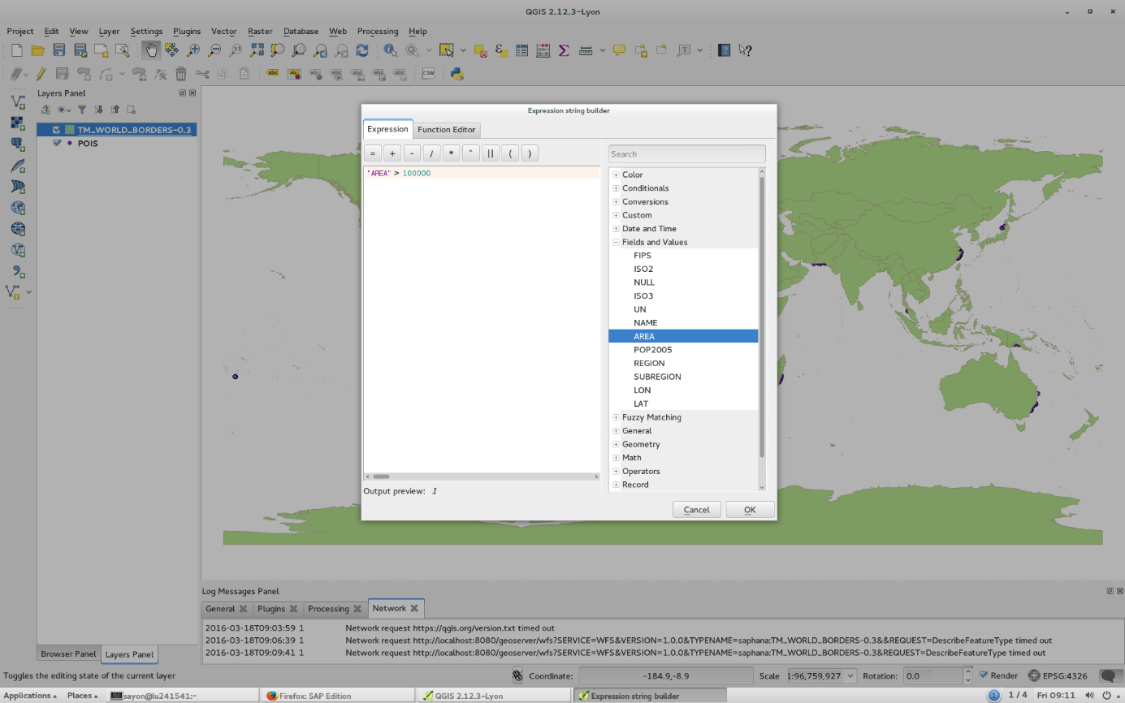

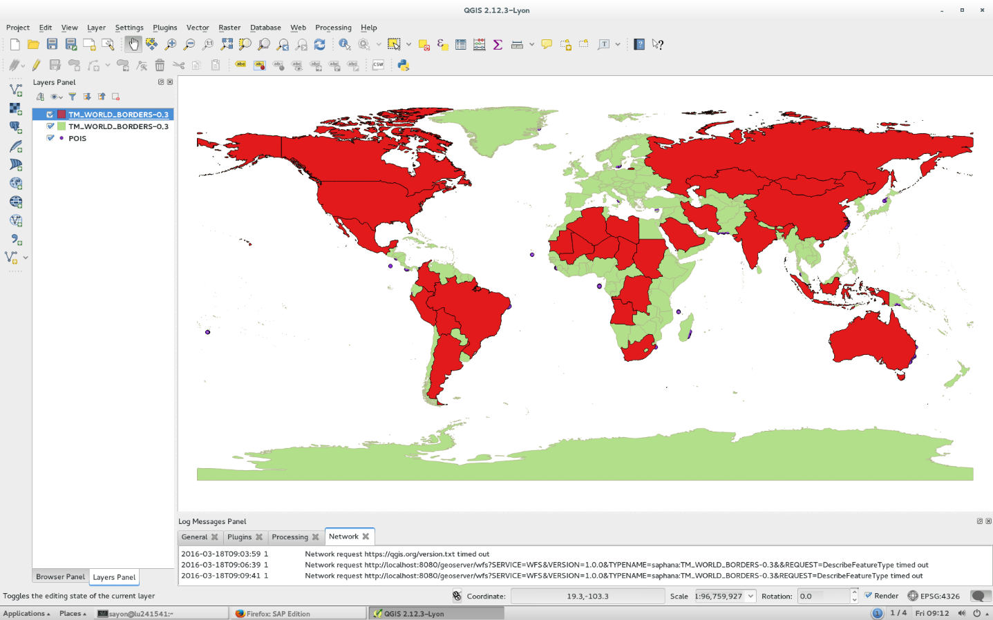The output of the map looks like below displaying countries that have area greater than the value 100000.

1. On the left **Layers** pane, right click on the layer **TM_WORLD_BORDERS-0.3**, then select **Properties.** A lot of other options can be explored here with regard to the given layer.

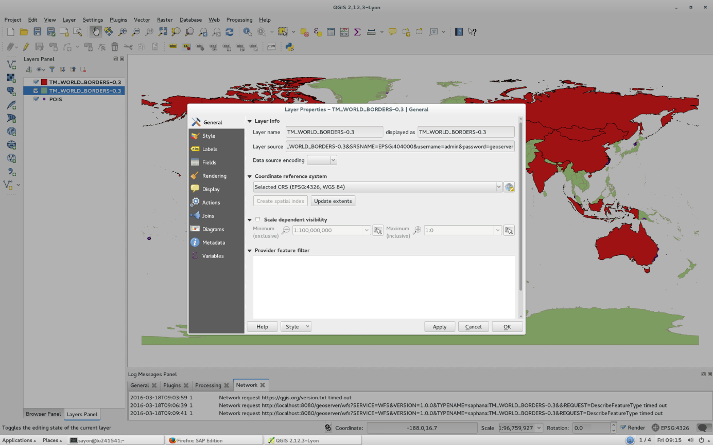

**13 WFS & Layer Styling in UDig for GeoServer**

**uDig** is a GIS software program produced by a community led by Canadian-based consulting company Refractions Research. In this Demo, we will see how WFS is consumed by uDig from GeoServer that uses the data from SAP HANA.

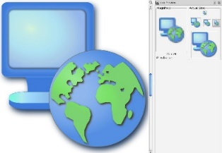

1. Download and install uDig. The latest uDig binary can be found at <http://udig.refractions.net/download/>.
2. Start uDig and Load the layers into uDig interface from GeoServer WFS protocol. The Add Layers panel can be opened by clicking **Layer**->**Add …** in the action bar in uDig. Select **Web Feature Server** in the menu, and then click **Next** to continue.
3. 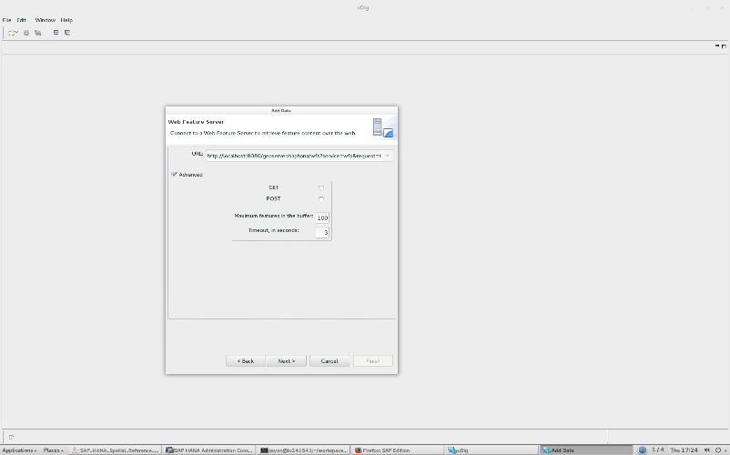Enter the following URL: http://localhost:8080/geoserver/saphana/wfs?service=wfs&request=GetCapabilities Then click **Next**.

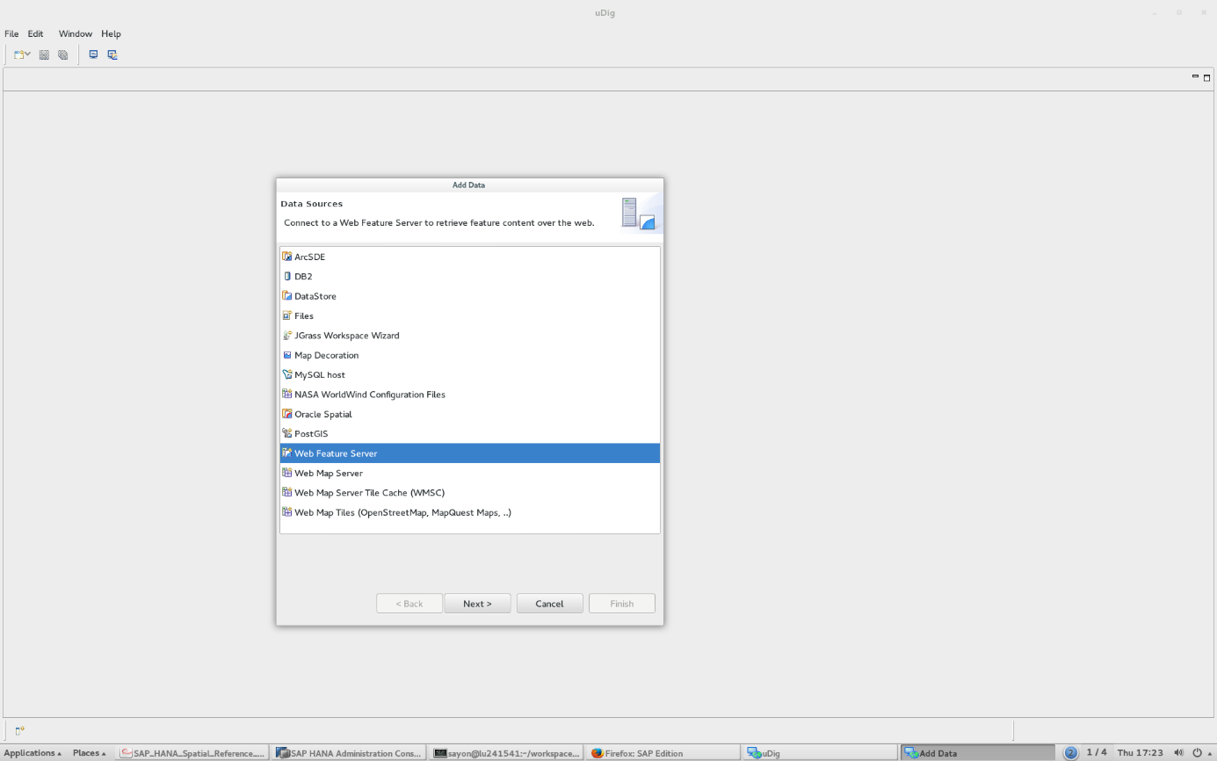

1. Select all layers and then click **Finish** to import the layers to uDig.

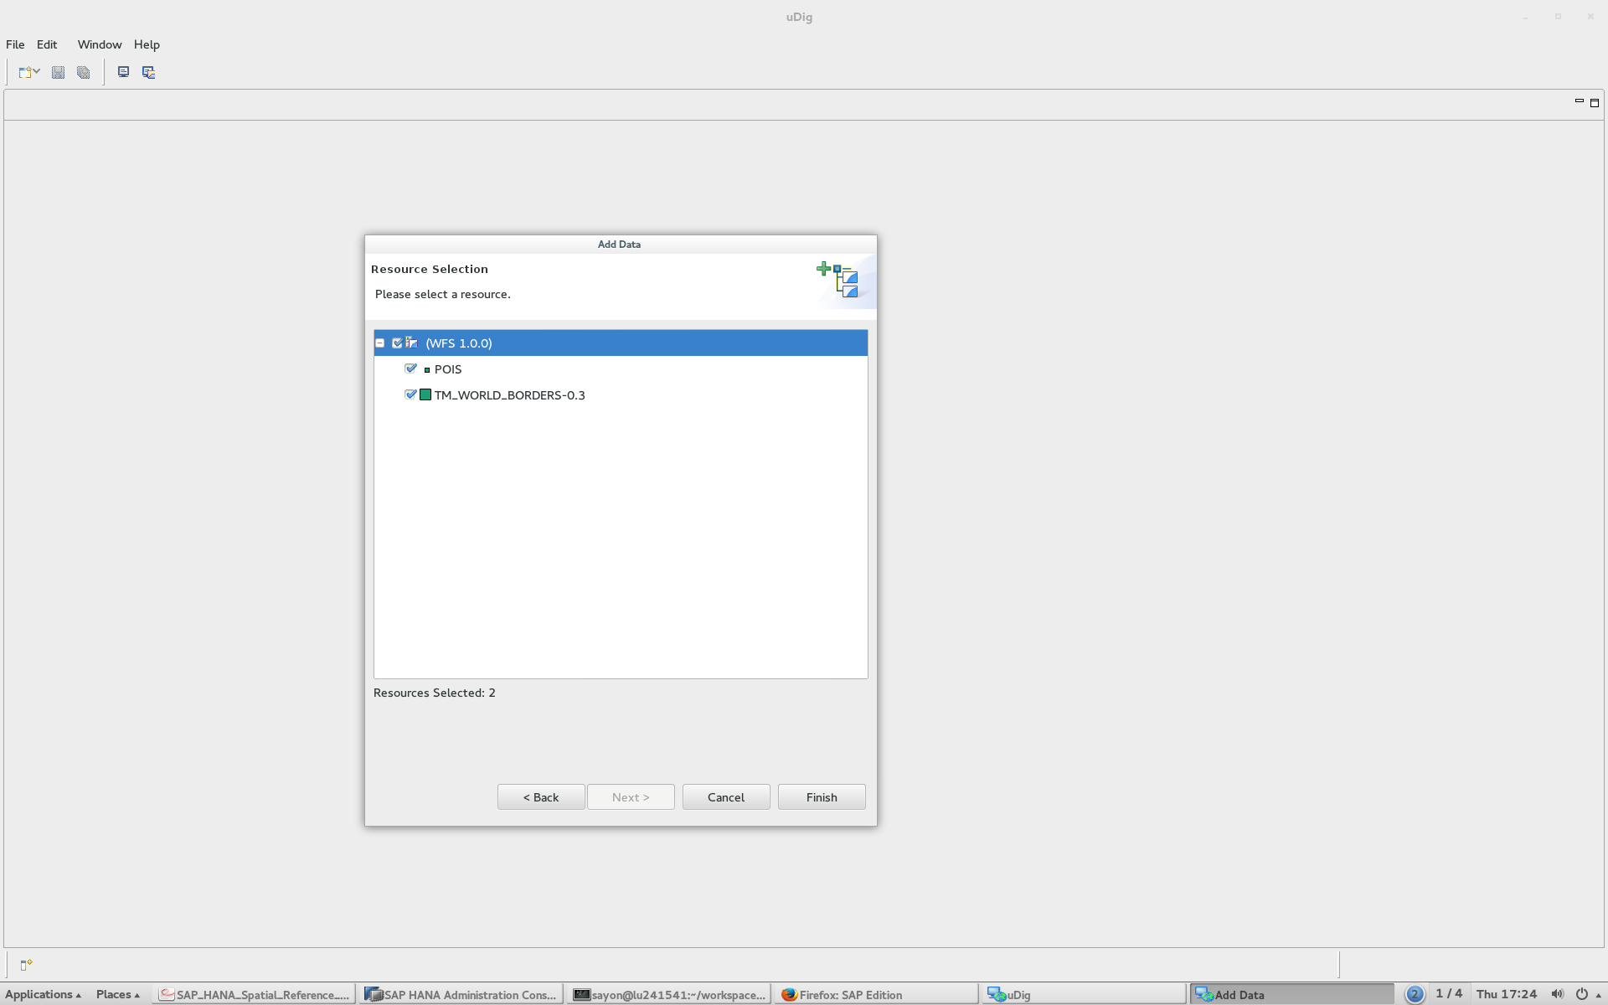

The output of the map looks like below.

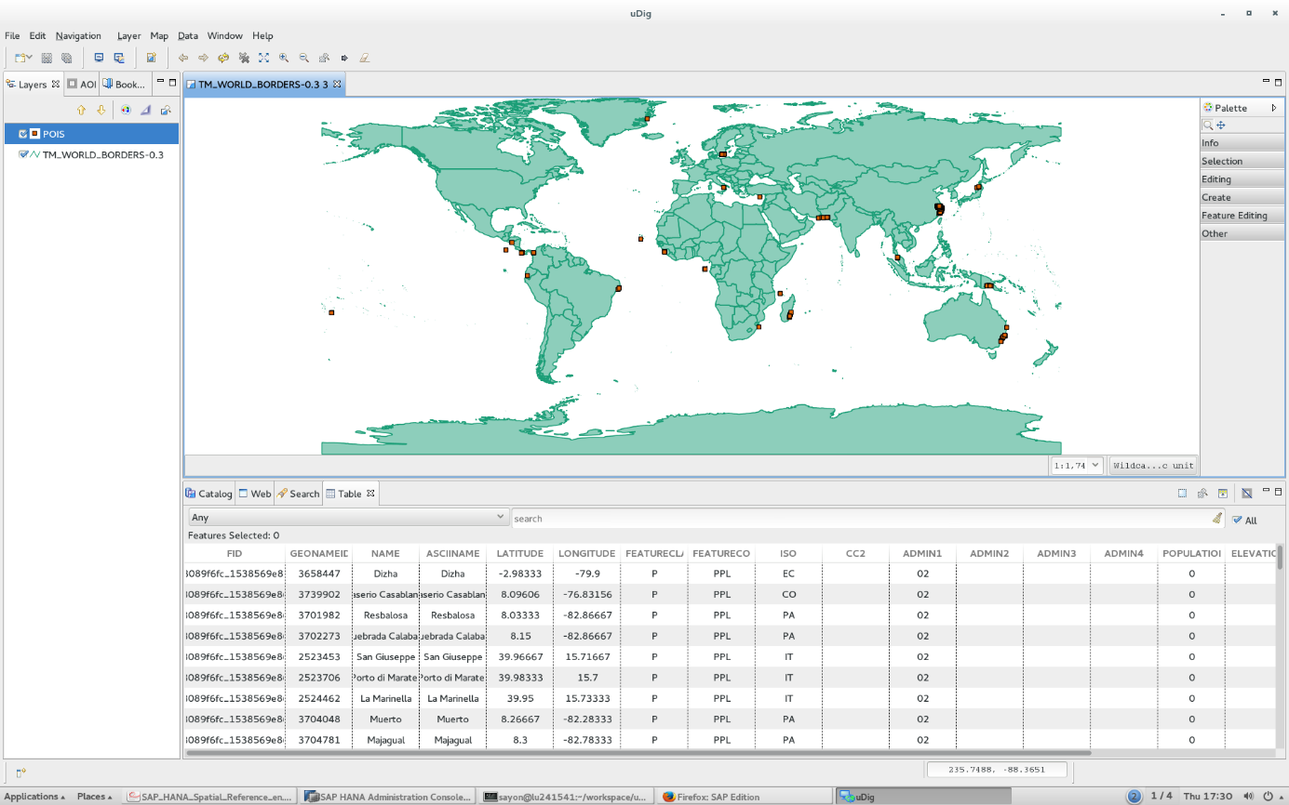

**GeoServer** uses a symbology system called **Styled Layer Descriptor (SLD),** which is a XML based file. However, instead of writing this SLD file by hand, we can use uDig (user-friendly Desktop Internet GIS) to create the file. Follow the following steps to create custom styles with uDig:

1. On the left **Layers** pane, right click on the layer **TM_WORLD_BORDERS-0.3**, then select **Change Style…** from the menu.
2. Select the choice **Theme** on the left pane of **Style Editor** Popup. A list of available themes will show.

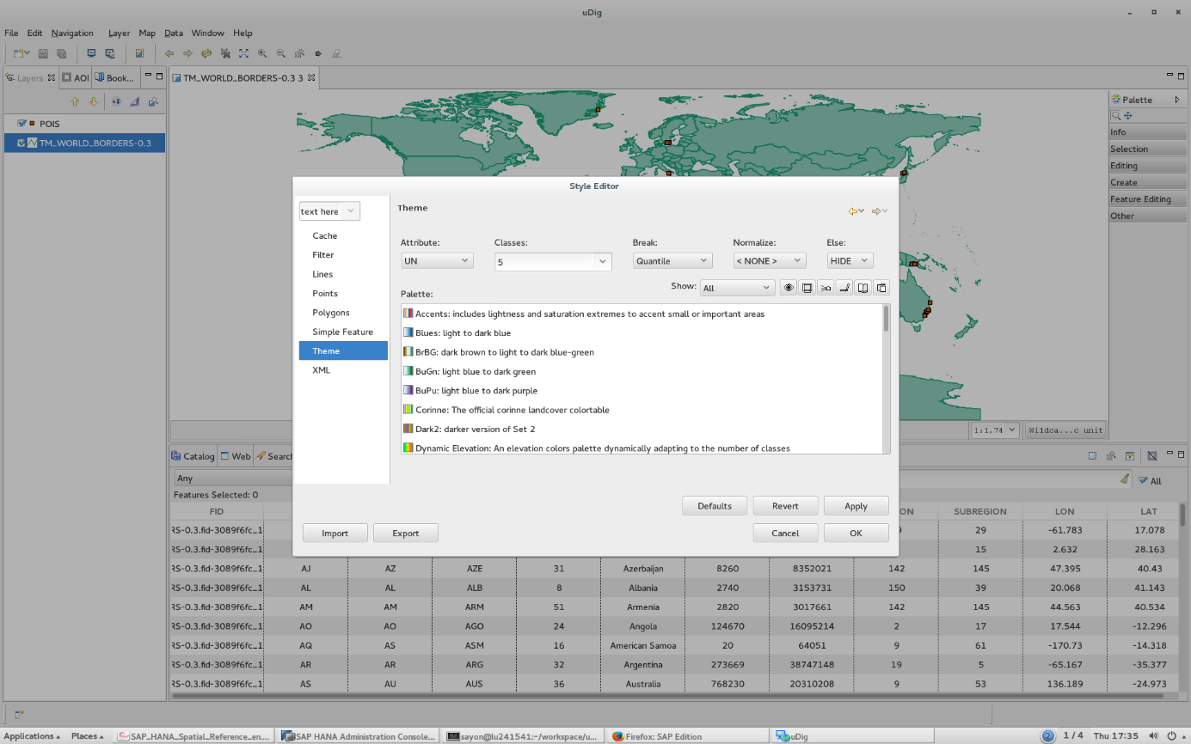

1. Click the **XML** tab on the left pane of **Style Editor** to view the resulting SLD XML file. You can either save it into a SLD file for later uses, or copy it into your clipboard cache.

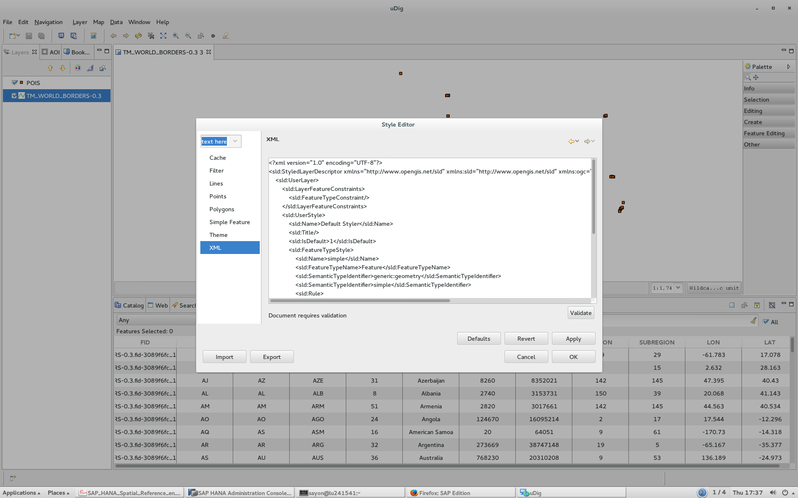

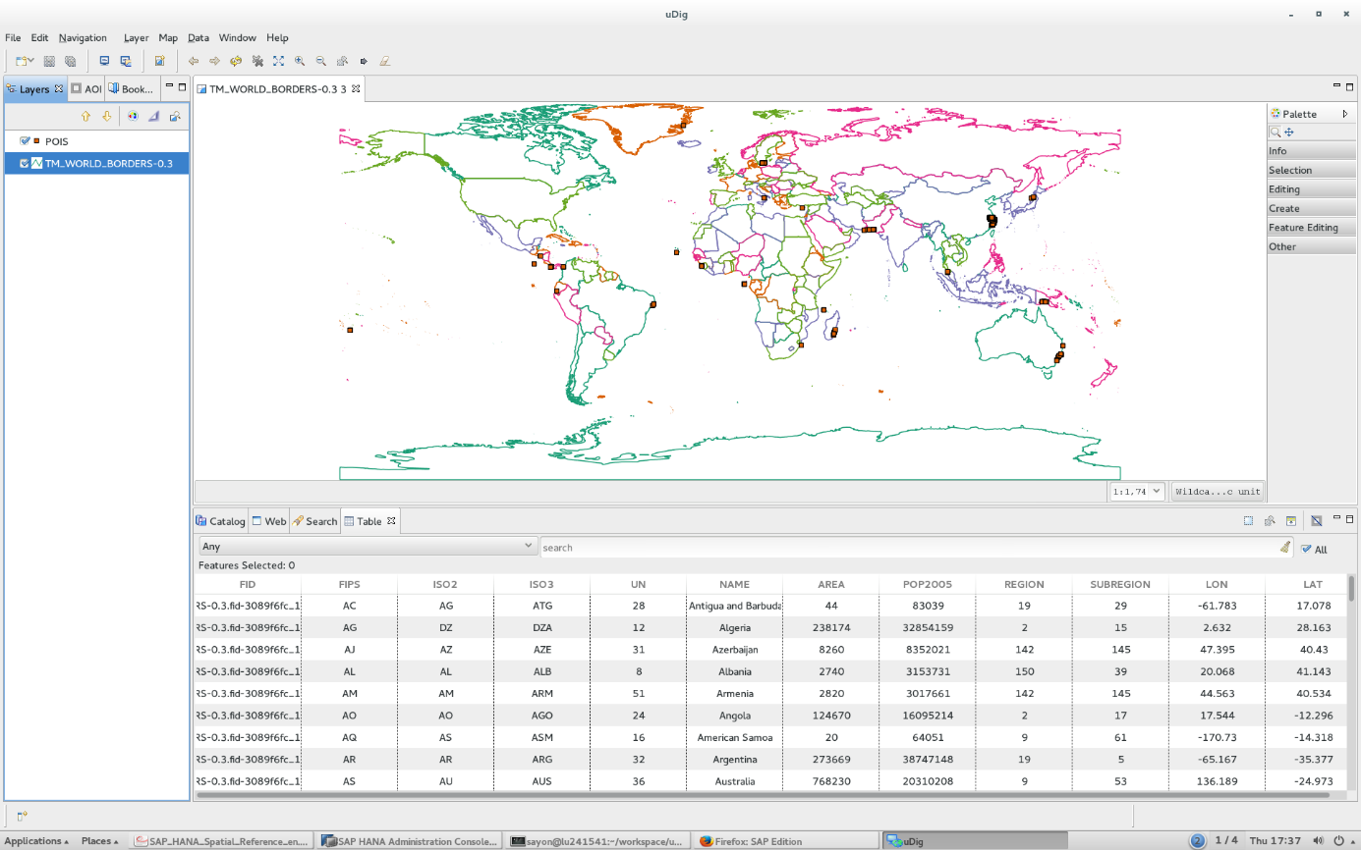The layer after applying the style looks like the following in QGIS. You can add this SLD file in the **Style** section of GeoServer explained earlier in the **Section 8 Customizing Layer Styles** to use the style in GeoServer.